

**Central Electronics Limited**

**Online File Tracking System**

A Project Report

Submitted by

**Sushant Verma**

In partial fulfilment for the award of the degree of

**BECHELOR OF ENGINEERING**

**IN**

**COMPUTER SCIENCE AND ENGINEERING**

GGSIP University

MAY 2018

**Acknowledgement**

The satisfaction and euphoria that accompany the successful completion of any task wouldn’t complete without the mention of the people who made it possible because success is epitome of hard work, undeterred missionary zeal, steadfast determination, unperturbed concentration and dedication and above all, apt advices.

My sincere gratitude and thanks to Mr. P.K Singh G.M. (HRD) of Central Electronics Limited (Uttar Pradesh) for his kind encouragement and blessings.

I would like to extend my gratitude to my Internal Guide, Ms. Preeti Malik M.C.A. for having their full co-operation and guidance. Without them, the project would not have been succeeded.

I would like to convey my sincere thanks to all who have guided all along my project and provided their valuable reviews, feedback and comments to improve and perfect myself.

I also thank all the staff members of HRD department for the views and comments on the project.

Finally, I wish to dedicate my gratefulness to everybody who played a major role in the successfulness of this project work.

**Contents**

Introduction 4

Central Electronics Limited (CEL): 5

CERTIFICATE 6

Technologies Used: 6

• HTML 6

• CSS 7

• PHP 8

• JavaScript 9

Existing System: 9

Proposed System: 10

Minimum System Requirements: 11

Coding of Pages: 13

Welcome Page: 13

Session File: 14

Connection file: 15

Style.css: 16

Login Page: 17

Sign-up page: 20

Change Password: 24

Home Page: 27

Logout page: 29

Generate Dak: 30

Discarding Generated Dak: 40

Pending Dak Requests: 41

Accepting a dak: 44

Rejecting a dak: 48

Received Daks : 51

Checking Status of Received dak: 57

Pending Daks for Forwarding: 64

Sending a Dak: 67

List of Generated Daks: 72

Tracking a Dak by dak number: 77

Searching a dak by specific word: 86

# **Introduction**

The project herein is an Online File Tracking System which is used to track down the current location as well as mapping of any document or the file within various divisions in the organisation. This helps the user in not losing the document in between its processing within various divisions.

The design leverages intelligent mechanism, cognitive approaches, classifier systems and a data driven approach for adaptive profiling and configuration of software behaviour, and serves as an effective engagement tool for information capture, collaboration and decision support in a distributed enterprise operation involving multiple stakeholders.

Here in this project, data is collected in a systematic approach which helps in establishing relations between the employee’s thereby supporting in understanding the role of each involved entity. And also for managing the employee’s responsibility an application has been developed, which has been allotted to that employee by corresponding section supervisor or higher authority, thereby measure of the employee’s role shown.

# **Central Electronics Limited (CEL):**

**Central Electronics Limited** is a Public Sector Enterprise under the department of Scientific and Industrial Research (DSIR), Ministry of Science and Technology, Government of India. It was established in 1974 with an objective to commercially exploit the indigenous technologies developed by National Laboratories and R&D Institutions in the country. CEL is one of the rare companies, which utilized the home-grown technologies during all these years of its existence.

CEL has developed a number of products for the first time in the country through its own R&D efforts and in the close association with the premier National & International Laboratories including Defence Laboratories. In recognition of all these efforts, CEL has been awarded a number of times with prestigious awards including “National Award for R&D by DSIR”.

CEL comprises of 5 major divisions namely Solar Photo Voltaic Division (SPV), Electronic Ceramic Division (ECD), Systems Production Division (SPD), Microwave Electronics Division (MED) and Cadmium Zinc Tellurium Division (CZT).

CEL is pioneer in the country in the field of Solar Photovoltaic (SPV) and it has developed state-of-the-art technology with its own R&D efforts. Its solar products have been qualified to International Standards EC503/IEC1215 by the European Commission, Joint Research Centre, and ISPRA, Italy.

CEL has developed a number of critical components for strategic applications and is supplying these items. Each of the divisions is responsible for its own manufacturing and functioning with the help of independent General Managers (GM) coordinating Supervisors and workers. The overall thinking of the company is supervised by the Chairman and Managing Director (CMD).

# **CERTIFICATE**

This is to certify that SUSHANT VERMA of Maharaja Agrasen Institute of Technology, Delhi has undergone industrial training at CENTRAL ELECTRONICS LIMITED (CEL): 4, Industrial Area, Sahibabad, Ghaziabad (U.P.) in the Human Resource and Development Division.

He is dedicated and hard working towards his work. His dedication and performance is good. I wish him all the success in the future.

Mr. P.K. Singh

General Manager ( HRD )

CENTRAL ELECTRONICS LIMITED

# **Technologies Used:**

* **HTML**

Hypertext Markup Language (HTML) is the standard [markup language](https://en.wikipedia.org/wiki/Markup_language) for creating [web pages](https://en.wikipedia.org/wiki/Web_page) and [web applications](https://en.wikipedia.org/wiki/Web_application). With [Cascading Style Sheets](https://en.wikipedia.org/wiki/Cascading_Style_Sheets) (CSS) and [JavaScript](https://en.wikipedia.org/wiki/JavaScript), it forms a triad of cornerstone technologies for the [World Wide Web](https://en.wikipedia.org/wiki/World_Wide_Web).

[Web browsers](https://en.wikipedia.org/wiki/Web_browser) receive HTML documents from a [web server](https://en.wikipedia.org/wiki/Web_server) or from local storage and [render](https://en.wikipedia.org/wiki/Browser_engine) the documents into multimedia web pages. HTML describes the structure of a web page [semantically](https://en.wikipedia.org/wiki/Semantic_Web) and originally included cues for the appearance of the document.

[HTML elements](https://en.wikipedia.org/wiki/HTML_element) are the building blocks of HTML pages. With HTML constructs, [images](https://en.wikipedia.org/wiki/HTML_element#Images_and_objects) and other objects such as [interactive forms](https://en.wikipedia.org/wiki/Fieldset) may be embedded into the rendered page. HTML provides a means to create [structured documents](https://en.wikipedia.org/wiki/Structured_document) by denoting structural [semantics](https://en.wikipedia.org/wiki/Semantics) for text such as headings, paragraphs, lists, [links](https://en.wikipedia.org/wiki/Hyperlink), quotes and other items. HTML elements are delineated by *tags*, written using [angle brackets](https://en.wikipedia.org/wiki/Bracket#Angle_brackets). Tags such as <img /> and <input /> directly introduce content into the page. Other tags such as <p> surround and provide information about document text and may include other tags as sub-elements. Browsers do not display the HTML tags, but use them to interpret the content of the page.

HTML can embed programs written in a [scripting language](https://en.wikipedia.org/wiki/Scripting_language) such as [JavaScript](https://en.wikipedia.org/wiki/JavaScript), which affects the behavior and content of web pages. Inclusion of CSS defines the look and layout of content. The [World Wide Web Consortium](https://en.wikipedia.org/wiki/World_Wide_Web_Consortium) (W3C), maintainer of both the HTML and the CSS standards, has encouraged the use of CSS over explicit presentational HTML since 1997.

* **CSS**

Cascading Style Sheets (CSS) is a [style sheet language](https://en.wikipedia.org/wiki/Style_sheet_language) used for describing the [presentation](https://en.wikipedia.org/wiki/Presentation_semantics) of a document written in a [markup language](https://en.wikipedia.org/wiki/Markup_language) like [HTML](https://en.wikipedia.org/wiki/HTML). CSS is a cornerstone technology of the [World Wide Web](https://en.wikipedia.org/wiki/World_Wide_Web), alongside HTML and [JavaScript](https://en.wikipedia.org/wiki/JavaScript).

CSS is designed to enable the separation of presentation and content, including [layout](https://en.wikipedia.org/wiki/Page_layout), [colors](https://en.wikipedia.org/wiki/Color), and [fonts](https://en.wikipedia.org/wiki/Typeface).[[3]](https://en.wikipedia.org/wiki/Cascading_Style_Sheets#cite_note-3) This separation can improve content [accessibility](https://en.wikipedia.org/wiki/Accessibility), provide more flexibility and control in the specification of presentation characteristics, enable multiple [web pages](https://en.wikipedia.org/wiki/Web_page) to share formatting by specifying the relevant CSS in a separate .css file, and reduce complexity and repetition in the structural content.

Separation of formatting and content also makes it feasible to present the same markup page in different styles for different rendering methods, such as on-screen, in print, by voice (via speech-based browser or [screen reader](https://en.wikipedia.org/wiki/Screen_reader)), and on [Braille-based](https://en.wikipedia.org/wiki/Braille_display) tactile devices. CSS also has rules for alternate formatting if the content is accessed on a [mobile device](https://en.wikipedia.org/wiki/Mobile_device).

The name *cascading* comes from the specified priority scheme to determine which style rule applies if more than one rule matches a particular element. This cascading priority scheme is predictable.

The CSS specifications are maintained by the [World Wide Web Consortium](https://en.wikipedia.org/wiki/World_Wide_Web_Consortium) (W3C). Internet media type ([MIME type](https://en.wikipedia.org/wiki/MIME_media_type)) text/css is registered for use with CSS by [RFC 2318](https://tools.ietf.org/html/rfc2318) (March 1998). The W3C operates a free [CSS validation service](https://en.wikipedia.org/wiki/W3C_Markup_Validation_Service#CSS_validation) for CSS documents.

In addition to HTML, other markup languages support the use of CSS, including [XHTML](https://en.wikipedia.org/wiki/XHTML), [plain XML](https://en.wikipedia.org/wiki/Plain_Old_XML), [SVG](https://en.wikipedia.org/wiki/Scalable_Vector_Graphics), and [XUL](https://en.wikipedia.org/wiki/XUL).

* **PHP**

PHP: Hypertext Preprocessor (or simply PHP) is a [server-side scripting](https://en.wikipedia.org/wiki/Server-side_scripting) language designed for [Web development](https://en.wikipedia.org/wiki/Web_development), but also used as a [general-purpose programming language](https://en.wikipedia.org/wiki/General-purpose_programming_language). It was originally created by [Rasmus Lerdorf](https://en.wikipedia.org/wiki/Rasmus_Lerdorf) in 1994, the PHP [reference implementation](https://en.wikipedia.org/wiki/Reference_implementation) is now produced by The PHP Group. PHP originally stood for *Personal Home Page*, but it now stands for the [recursive acronym](https://en.wikipedia.org/wiki/Recursive_acronym) *PHP: Hypertext Preprocessor*.

PHP code may be embedded into [HTML](https://en.wikipedia.org/wiki/HTML) code, or it can be used in combination with various [web template systems](https://en.wikipedia.org/wiki/Web_template_system), web content management systems, and [web frameworks](https://en.wikipedia.org/wiki/Web_framework). PHP code is usually processed by a PHP [interpreter](https://en.wikipedia.org/wiki/Interpreter_(computing)) implemented as a [module](https://en.wikipedia.org/wiki/Plugin_(computing)) in the web server or as a [Common Gateway Interface](https://en.wikipedia.org/wiki/Common_Gateway_Interface) (CGI) executable. The web server combines the results of the interpreted and executed PHP code, which may be any type of data, including images, with the generated web page. PHP code may also be executed with a [command-line interface](https://en.wikipedia.org/wiki/Command-line_interface) (CLI) and can be used to implement [standalone](https://en.wikipedia.org/wiki/Computer_software) [graphical applications](https://en.wikipedia.org/wiki/Graphical_user_interface).

The standard PHP interpreter, powered by the [Zend Engine](https://en.wikipedia.org/wiki/Zend_Engine), is [free software](https://en.wikipedia.org/wiki/Free_software) released under the [PHP License](https://en.wikipedia.org/wiki/PHP_License). PHP has been widely ported and can be deployed on most web servers on almost every [operating system](https://en.wikipedia.org/wiki/Operating_system) and [platform](https://en.wikipedia.org/wiki/Computing_platform), free of charge.

The PHP language evolved without a written [formal specification](https://en.wikipedia.org/wiki/Formal_specification) or standard until 2014, with the original implementation acting as the [*de facto*](https://en.wikipedia.org/wiki/De_facto) standard which other implementations aimed to follow. Since 2014 work has gone on to create a formal PHP specification

.

During the 2010s there have been increased efforts towards standardisation and code sharing in PHP applications by projects such as [PHP-FIG](http://www.php-fig.org/) in the form of [PSR initiatives](http://www.php-fig.org/psr/) as well as the [Composer dependency manager](https://en.wikipedia.org/wiki/Composer_(software)) and associated [Packagist repository](https://packagist.org/). PHP hosts a diverse array of web frameworks requiring framework-specific knowledge, with [Laravel](https://en.wikipedia.org/wiki/Laravel) recently emerging as a popular option by incorporating ideas made popular from other competing non-PHP web frameworks, like [Ruby on Rails](https://en.wikipedia.org/wiki/Ruby_on_Rails).

* **JavaScript**

JavaScript often abbreviated as JS, is a [high-level](https://en.wikipedia.org/wiki/High-level_programming_language), [interpreted](https://en.wikipedia.org/wiki/Interpreted_language) [programming language](https://en.wikipedia.org/wiki/Programming_language). It is a language which is also characterized as [dynamic](https://en.wikipedia.org/wiki/Dynamic_programming_language), [weakly typed](https://en.wikipedia.org/wiki/Weak_typing), [prototype-based](https://en.wikipedia.org/wiki/Prototype-based_programming) and [multi-paradigm](https://en.wikipedia.org/wiki/Multi-paradigm_programming_language).

Alongside [HTML](https://en.wikipedia.org/wiki/HTML) and [CSS](https://en.wikipedia.org/wiki/CSS), JavaScript is one of the three core technologies of the [World Wide Web](https://en.wikipedia.org/wiki/World_Wide_Web). JavaScript enables interactive [web pages](https://en.wikipedia.org/wiki/Web_page) and thus is an essential part of [web applications](https://en.wikipedia.org/wiki/Web_application). The vast majority of [websites](https://en.wikipedia.org/wiki/Website) use it, and all major [web browsers](https://en.wikipedia.org/wiki/Web_browser) have a dedicated [JavaScript engine](https://en.wikipedia.org/wiki/JavaScript_engine) to execute it.

As a multi-paradigm language, JavaScript supports [event-driven](https://en.wikipedia.org/wiki/Event-driven_programming), [functional](https://en.wikipedia.org/wiki/Functional_programming), and [imperative](https://en.wikipedia.org/wiki/Imperative_programming) (including [object-oriented](https://en.wikipedia.org/wiki/Object-oriented_programming) and [prototype-based](https://en.wikipedia.org/wiki/Prototype-based_programming)) [programming styles](https://en.wikipedia.org/wiki/Programming_paradigm). It has an [API](https://en.wikipedia.org/wiki/Application_programming_interface) for working with text, [arrays](https://en.wikipedia.org/wiki/Array_data_type), dates, [regular expressions](https://en.wikipedia.org/wiki/Regular_expression), and basic manipulation of the [DOM](https://en.wikipedia.org/wiki/Document_Object_Model), but the language itself does not include any [I/O](https://en.wikipedia.org/wiki/Input/output), such as networking, storage, or graphics facilities, relying for these upon the host environment in which it is embedded.

Initially only implemented [client-side](https://en.wikipedia.org/wiki/Client-side) in web browsers, JavaScript engines are now embedded in many other types of host software, including [server-side](https://en.wikipedia.org/wiki/Server-side) in web servers and databases, and in non-web programs such as word processors and [PDF](https://en.wikipedia.org/wiki/Portable_Document_Format) software, and in runtime environments that make JavaScript available for writing mobile and desktop applications, including desktop widgets.

Although there are strong outward similarities between JavaScript and [Java](https://en.wikipedia.org/wiki/Java_(programming_language)), including language name, [syntax](https://en.wikipedia.org/wiki/Syntax_(programming_languages)), and respective [standard libraries](https://en.wikipedia.org/wiki/Standard_library), the two languages are distinct and differ greatly in design; JavaScript was influenced by programming languages such as [Self](https://en.wikipedia.org/wiki/Self_(programming_language)) and [Scheme](https://en.wikipedia.org/wiki/Scheme_(programming_language)).

# **Existing System:**

A dak could be a noting, a letter, a document, a file, an office order, etc. According to the existing system, the record of the daks is maintained over registers in hard copy. Whenever a dak is sent an entry is done into the register regarding the date of forwarding, Subject of the dak, dispatched to, and signature of the executive it is dispatched by. The subject of the dak includes the File number and the dak number along with the brief description of the dak.

When a dak is generated by a department and is sent to another employee of either same or another department, an entry is done into to dak register regarding that. If the dak is sent within the same department it is considered to be internal dak and if the dak is sent to another department it is considered to be external.

An individual is allotted to every executive who is responsible for managing the daks of the particular individual. And if the dak is dispatched in the name of a particular individual then it is managed by the Head of the Department of the particular department.

Since the records are maintained over the registers, it is very difficult to track down any dak. This is one of the main disadvantage of the existing system. It is practically very difficult to track down the present location of the dak if you don’t have any idea about the last entry regarding that dak within the register. Another disadvantage was that it is very difficult to maintain a lot of registers and find a particular entry regarding a particular dak.

# **Proposed System:**

The proposed system is an online application for the tracking of the daks. This application is based on the data collected on regular basis ever time when a dak is generated or sent by the executives who manage the daks. In this application, firstly the individual accounts are allotted to those executives who are responsible for dak management of an individual. On creation of account Code ID and passwords are allotted to each person.

When a dak is generated, an entry is done into the application, which includes Brief description of the dak, Number of pages, File number, Type of the dak and Designation and department of the person it is dispatched to. On the entry, a unique document ID and document number is generated in reference to that dak. Then a request is sent to the Account of the person who manages the daks of that particular individual, if the person accepts the dak that is considered as accepted, of the person rejects the dak it is considered as rejected and the user has to give an appropriate reason for the rejection and if the user neither accepts of rejects the dak it is considered as In-transit. According to the database is updated.

A user can only forward the dak after accepting it. Once dak is accepted, the user can take fill if any action is taken by them in its regard such as if any dak in its reference is generated or not. User can also forward the same dak is required to any executive as per the requirement.

If user wants to check the status of any dak, it can be searched either by using the dak number or either by using any specific work in the description of the dak. On searching the user can track the complete map of the dak since its generation and find the current location of the dak. User can also find out the Generation Details of that particular dak such as whom it is generated by, generation date, and other details.

The proposed system is very user friendly. It increases the efficiency of work. It saves the time as the tracking of the daks is a lot easier by this method as user needs not to find the dak entries in the stack of registers. The proposed system also brings the transparency of information in the organisation. Tracking of dak is also a lot easier by this method as the user can track each and every information about any dak just by using the dak number. It’s also environment friendly as it increases the paper saving.

# **Minimum System Requirements:**

**Web Browser –** Google Chrome

**Requirements for Windows:**

Pentium 4 processor or higher

approximately 100MB of free hard drive space

128MB of RAM

Windows XP with Service Pack 2, Windows Vista or Windows 7

**Requirements for Macintosh:**

Intel-powered Macs

100MB of hard disk space

128MB of RAM

OS X version 10.5.6 or later

**Requirements for Linux:**

* Pentium III
* 100MB of hard disk space
* 128MB of RAM
* Linux distributions from 2010
* Ubuntu 10.04 and later, Debian 6 or later, OpenSUSE 11.3 or later, and version 14 or later of Fedora

# **Coding of Pages:**

## Welcome Page:

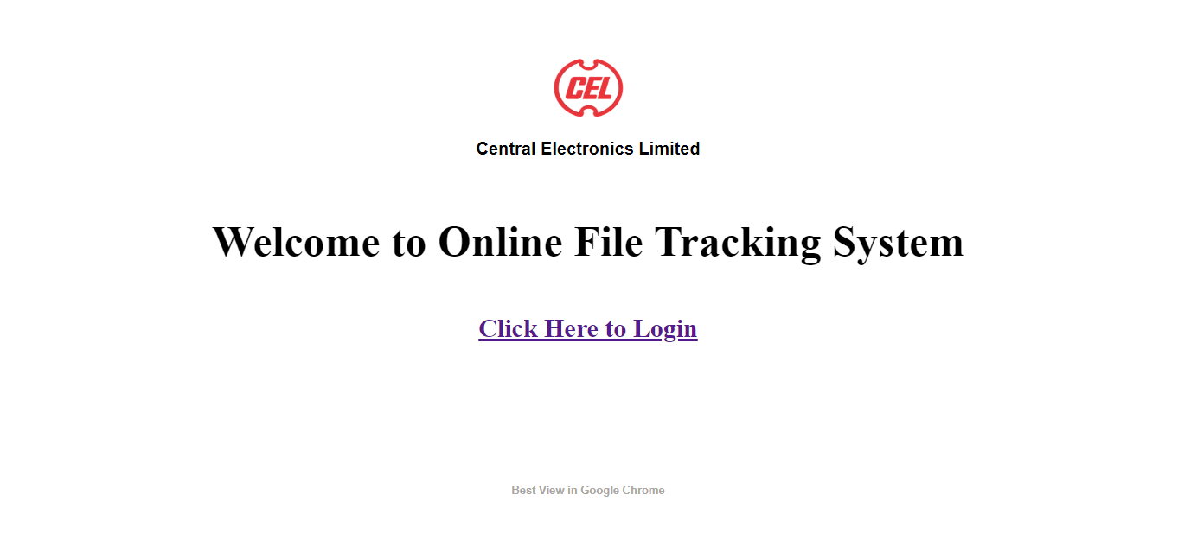

<!DOCTYPE html>

<html>

<head>

<title> Welcome to CEL </title>

<link rel="stylesheet" type="text/css" href="style.css">

</head>

<body>

<img src = "imgs/logo.png">

<h3 style= "font-family : 'Arial'; font-size : 20px;"> Central Electronics Limited </h3>

<h1 style="font-size : 50px ; font-family : 'book antique'; color : 1F1E1D;margin-top : 6%;"> Welcome to Online File Tracking System </h1>

<h2 style= "font-size : 30px;margin-top: 5%;">

<a href = "login.php">Click Here to Login </a>

</h2>

<h3 style= "font-family : 'Arial'; font-size : 13px;margin-top : 15%;color : #AAA7A3;"> Best View in Google Chrome </h3>

</body>

</html>

## Session File:

<?php

include('config.php');

session_start();

$db = db_open();

$user_check = $_SESSION['login_user'];

$ses_sql = mysqli_query($db,"select username from admin where username = '$user_check' ");

$row = mysqli_fetch_array($ses_sql,$db);

$login_session = $row['username'];

if(!isset($_SESSION['login_user'])){

header("location:login.php");

}

?>

## Connection file:

<?php

ini_set( "display_errors", 0);

function db_open()

{

// connecting with Database

$conn = mysql_connect("localhost","root","");

if(!$conn)

{

die('Could not connect: ' . mysql_error());

}

mysql_select_db("one",$conn);

return $conn;

}

function db_close($conn)

{

mysql_close($conn);

}

?>

## Style.css:

img

{

width : 65px;

height : 55px;

border : 2px;

margin-left : 15px;

margin-top : 15px;

position: absolute; top: 0; left: 0;

}

body

{

text-align : center;

margin-left : 10%;

margin-right : 10%;

min-width : 80%;

margin-top : 5%;

font-family : 'book antique';

}

label

{

font-weight : bold;

width : 100px;

font-size : 18px;

font-family : 'book antique';

}.box

{

border:#666666 solid 1px;

}

## Login Page:

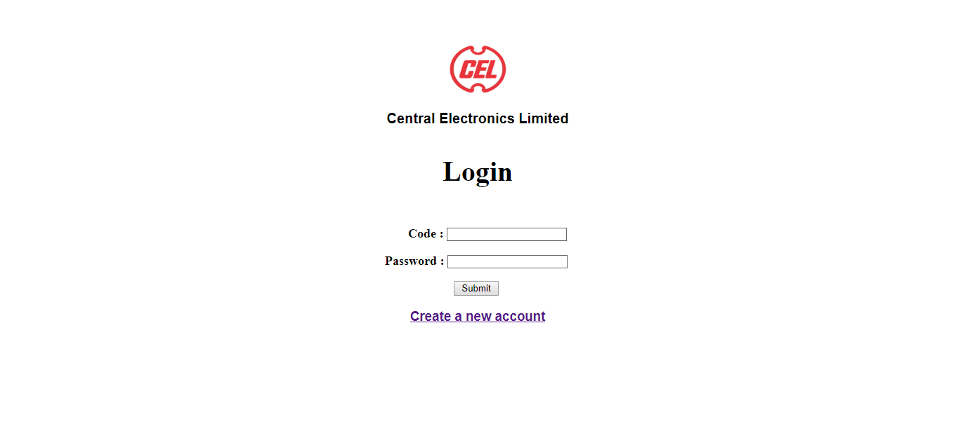

<!DOCTYPE html>

<?php

include('config.php');

ini_set('display_errors',0);

session_start();

$error="";

$db = db_open();

if($_SERVER["REQUEST_METHOD"] == "POST") {

$Code = $_POST['Code'];

$pass = $_POST['password'];

$result = mysql_query( "SELECT * FROM emp WHERE code = '$Code' and password = '$pass'",$db);

$row = mysql_fetch_array($result);

$count = mysql_num_rows($result);

if($count == 1) {

$_SESSION['login_user'] = $Code;

header("location: home.php?user=$Code");

}else {

$error = "Your Login Name or Password is invalid!";

}

}

?>

<html>

<head>

<title> Login </title>

<link rel="stylesheet" type="text/css" href="style.css">

</head>

<body>

<img src = "imgs/logo.png">

<h3 style= "font-family : 'Arial'; font-size : 20px;"> Central Electronics Limited </h3>

<h3 style= "font-family : 'Arial'; font-size : 40px;font-family : 'book antique';"> Login </h3>

<form action = "" method = "post" style="margin-top:5%;" autocomplete = "off">

<label Style = "margin-left : 32px"> Code : </label>

<input type = "text" name = "Code" class = "box" required>

<br />

<br />

<label> Password : </label>

<input type = "password" name = "password" class = "box" required>

<br/>

<br />

<input type = "submit" value = " Submit "/>

<br />

</form>

<div style = "font-size:11px; color:#cc0000; margin-top:10px">

<?php echo $error; ?>

</div>

<h3 style= "font-family : 'Arial'; font-size : 40;">

<a href = "signup.php"> Create a new account </a>

</h3>

</body>

</html>

## Sign-up page:

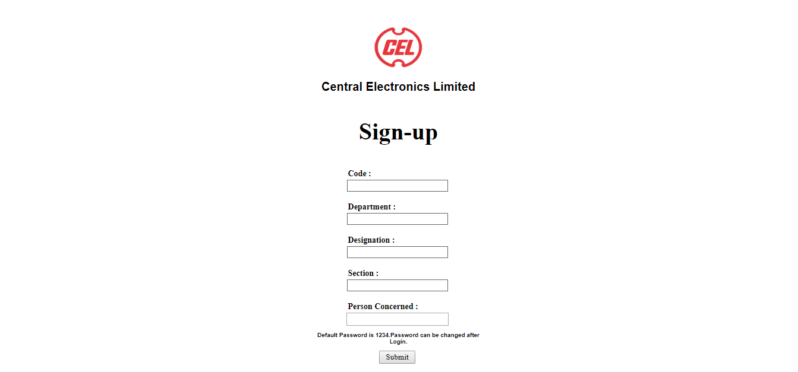

<?php

include('config.php');

session_start();

ini_set('display_errors',0);

$error="";

$db = db_open();

if($_SERVER["REQUEST_METHOD"] == "POST") {

$pass = "1234";

$code = $_POST['code'];

$depart = $_POST['deprt'];

$desig = $_POST['desig'];

$sect = $_POST['sect'];

$pcon = $_POST['pcon'];

$result1 = mysql_query(" Select id from emp WHERE code = '$code' ", $db);

$count1 = mysql_num_rows($result1);

if($count1 == 0) {

$s="INSERT into emp values ('".$code."','".$pass."','".$depart."','".$desig."','".$sect."','".$pcon."')";

mysql_query( $s,$db);

$_SESSION['login_user'] = $code;

header("location: changepassword.php");

}

else{

$error = "Code Already Exists in the Database.";

}

}

?>

<html>

<head>

<title> Sign-up </title>

<link rel="stylesheet" type="text/css" href="style.css">

</head>

<body>

<img src = "imgs/logo.png">

<h3 style= "font-family : 'Arial'; font-size : 20px;"> Central Electronics Limited </h3>

<h3 style= " font-size : 40px;font-family : 'book antique';"> Sign-up </h3>

<div align = "center" Style = "text-align : 'left';font-family : 'book antique';">

<div style = "width:300px; " align = "center">

<form action = "" method = "post" style="margin-top:5%; " autocomplete = "off">

<label> Code : </label>

<br />

<input type = "number" name = "code" class = "box" required>

<br />

<br />

<label> Department : </label>

<br />

<input type = "text" name = "deprt" class = "box" required>

<br />

<br />

<label> Designation : </label>

<br />

<input type = "text" name = "desig" class = "box" required>

<br />

<br />

<label> Section : </label>

<br />

<input type = "text" name = "sect" class = "box" required>

<br />

<br />

<label> Person Concerned : </label>

<br />

<input list="Person Concerned" name="pcon" required>

<datalist id="Person Concerned">

<option value="GM">GM</option>

<option value="AGM">AGM</option>

<option value="ED">ED</option>

<option value="TO">TO</option>

<option value="CM">CM</option>

<option value="CMD">CMD</option>

</datalist>

<br />

<h3 style= "font-family : 'Arial'; font-size : 10px;">Default Password is 1234.Password can be changed after Login.</h3>

<input type = "submit" value = " Submit " />

<br />

</form>

</div>

</div>

<div style = "font-size:11px; color:#cc0000; margin-top:10px">

<?php echo $error; ?>

</div>

</body>

</html>

## Change Password:

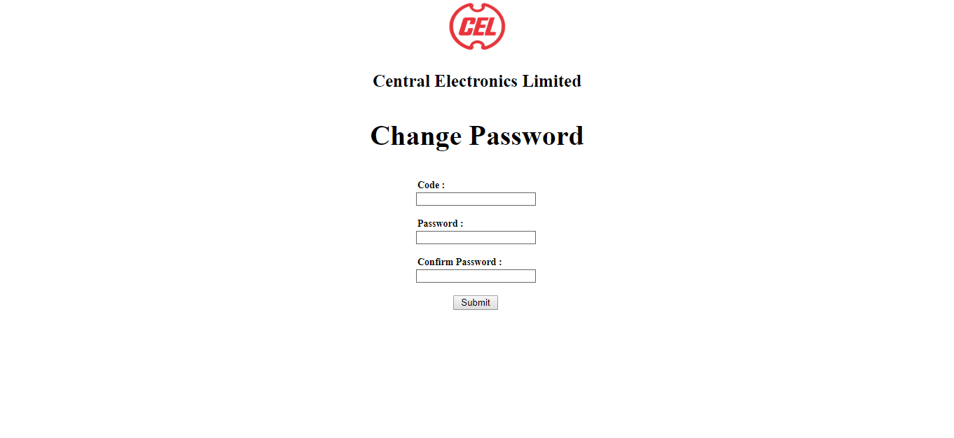

<!DOCTYPE html>

<html>

<head>

<title> Change Password </title>

<link rel="stylesheet" type="text/css" href="style.css">

</head>

<?php

include('config.php');

session_start();

ini_set('display_errors',0);

$error="";

$db = db_open();

if($_SERVER["REQUEST_METHOD"] == "POST") {

$code = $_POST['code'];

$pass = $_POST['pass'];

$cpass = $_POST['cpass'];

if($pass == $cpass)

{

$result1=mysql_query("Select code from emp WHERE code = '$code'", $db);

$count1 = mysql_num_rows($result1);

if($count1 == 1) {

mysql_query( "UPDATE emp set password = '$pass' where code = '$code'",$db);

header("location: home.php?user=$code");

}else {

$error = "ID Does not Exists in the Database.";

}

}else

$error = "Passwords doesn't match.";

}

?>

<body>

<img src = "imgs/logo.png">

<h3 style= "font-family : 'Arial'; font-size : 25px;font-family : 'book antique';"> Central Electronics Limited </h3>

<h3 style= "font-family : 'Arial'; font-size : 40px;font-family : 'book antique';"> Change Password </h3>

<div align = "center" Style = "text-align : 'left';font-family : 'book antique';">

<div style = "width:300px; " align = "center">

<form action = "" method = "post" style="margin-top:5%; ">

<label> Code : </label>

<br />

<input type = "text" name = "code" class = "box"/>

<br />

<br />

<label> Password : </label>

<br />

<input type = "password" name = "pass" class = "box"/>

<br />

<br />

<label> Confirm Password : </label>

<br />

<input type = "password" name = "cpass" class = "box"/>

<br />

<br />

<input type = "submit" value = " Submit " />

<br />

</form>

</div>

</div>

<div style = "font-size:11px; color:#cc0000; margin-top:10px">

<?php echo $error; ?>

</div>

</body>

</html>

## Home Page:

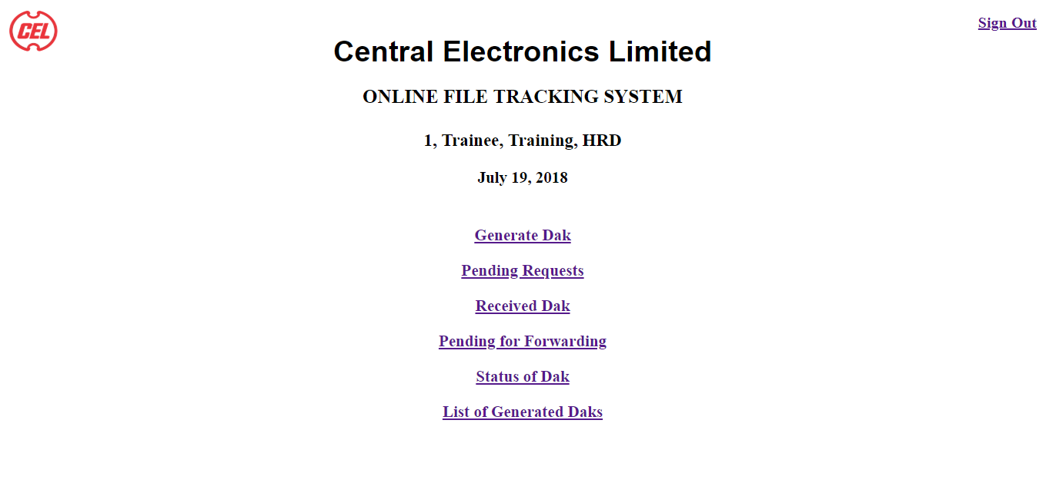

<!DOCTYPE html>

<?php

include('session.php');

ini_set('display_errors',0);

$code=$_GET['user'];

$result = mysql_query( "SELECT * FROM emp WHERE code = '$code'",$db);

$row = mysql_fetch_assoc($result);

$depart = $row['department'];

$desig = $row['designation'];

$sect = $row['section'];

?>

<html>

<head>

<title> CEL </title>

<link rel="stylesheet" type="text/css" href="style.css">

</head>

<body>

<img src = "imgs/logo.png">

<h3 style= "font-family : 'Arial'; font-size : 38px; align : center;margin-top : -20px"> Central Electronics Limited </h3>

<h2 style= "position: absolute; top: 0; right: 0;font-size : 20px; margin-right: 15px; margin-top : 20px;">

<a href = "logout.php" >Sign Out</a>

</h2>

<h1 style= "font-family : 'book antique'; font-size : 25px; align : center; margin-top : -15px;"> ONLINE FILE TRACKING SYSTEM </h1>

<h3 style= "font-family : 'book antique'; font-size : 23px; align : center; margin-top : 30px;">

<?php echo ucwords($code).", ". ucwords($desig).", ".ucwords($sect).", ". strtoupper($depart) ?>

</h3>

<h3 style= "font-family : 'book antique'; font-size : 21px; align : center; margin-top : 20px;">

<?php echo date('F d, Y')?>

</h3>

<h3 style= "font-family : 'book antique'; font-size : 21px; align : center; margin-top : 50px;">

<a href = "gen.php?id=<?php echo $code; ?>"> Generate Dak </a>

</h3>

<h3 style= "font-family : 'book antique'; font-size : 21px; align : center; margin-top : 20px;">

<a href = "recreq.php?id=<?php echo $code; ?>" > Pending Requests </a>

</h3>

<h3 style= "font-family : 'book antique'; font-size : 21px; align : center; margin-top : 20px;">

<a href = "recd.php?id=<?php echo $code; ?>" > Received Dak </a>

</h3>

<h3 style= "font-family : 'book antique'; font-size : 21px; align : center; margin-top : 20px;">

<a href = "send.php?id=<?php echo $code; ?>" > Pending for Forwarding </a>

</h3>

<h3 style= "font-family : 'book antique'; font-size : 21px; align : center; margin-top : 20px;">

<a href = "stat.php?id=<?php echo $code; ?>" > Status of Dak </a>

</h3>

<h3 style= "font-family : 'book antique'; font-size : 21px; align : center; margin-top : 20px;">

<a href = "listgen.php?id=<?php echo $code; ?>" > List of Generated Daks </a>

</h3>

</body>

</html>

## Logout page:

<?php

session_start();

if(session_destroy()) {

header("Location: login.php");

}

?>

## Generate Dak:

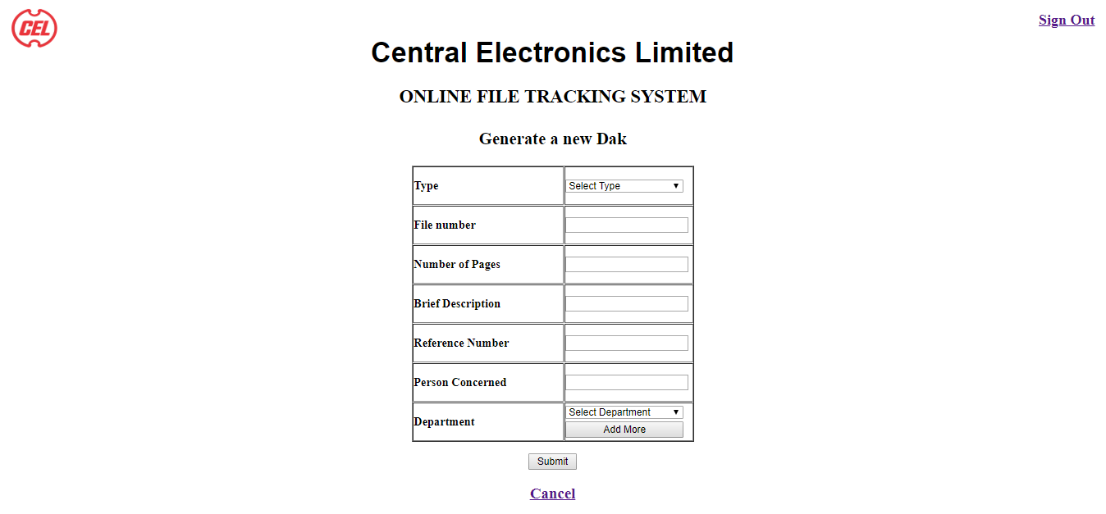

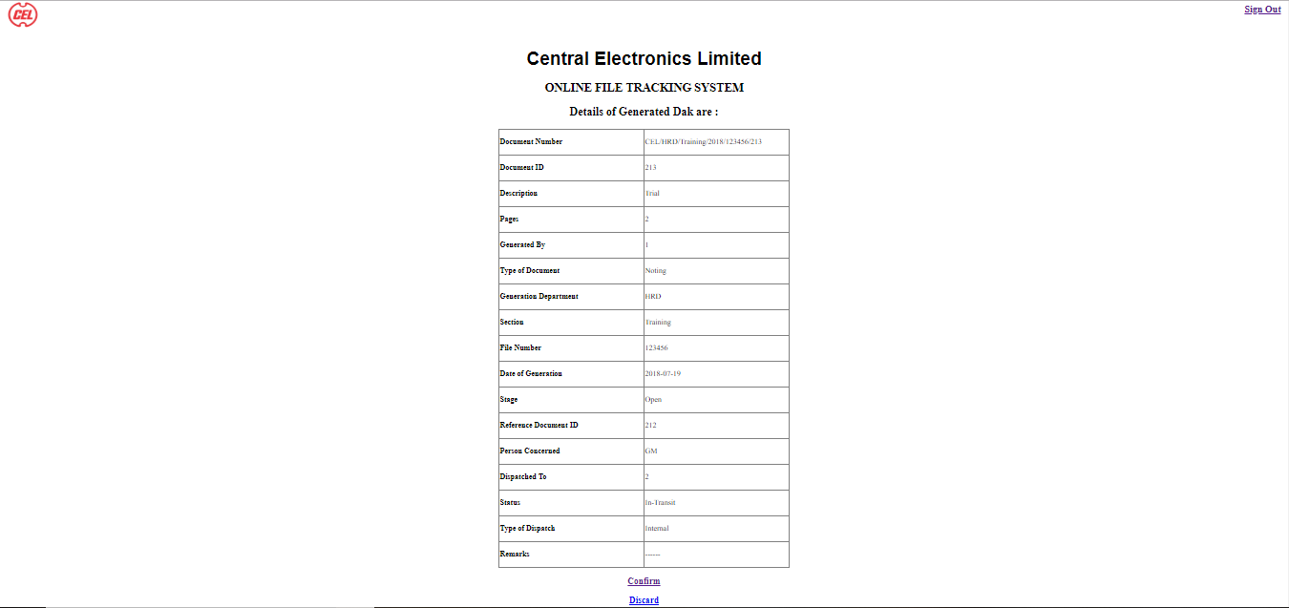

<!DOCTYPE html>

<?php

include('session.php');

ini_set('display_errors',0);

$db = db_open();

$code=$_GET['id'];

$result = mysql_query( "SELECT * FROM emp WHERE code = '$code'",$db);

$row = mysql_fetch_assoc($result);

$depart = $row['department'];

$desig = $row['designation'];

$sect = $row['section'];

$gdate = date('Y-m-d');

$doc_id = "";

$error = "";

$row4 = "";

$a=0;

$y=1;

$all=mysql_query("SELECT * FROM track ORDER BY Doc_id DESC",$db);

if($_SERVER["REQUEST_METHOD"] == "POST") {

$des = $_POST['des'];

$fno = $_POST['fno'];

$pcon = $_POST['pcon'];

$pgs = $_POST['pgs'];

$doctype = $_POST['type'];

$dep = $_POST['dep'];

$ref = $_POST['ref'];

$status = "In-Transit";

$fetch1 = mysql_query("Select * from emp Where Person_concerned = '$pcon'",$db);

$row1 = mysql_fetch_assoc($fetch1);

$dto = $row1['code'];

$defid = -1;

if($dep == $depart)

$type = "Internal";

else

$type = "External";

$n="NULL";

if( $fno == "" )

{

mysql_query("INSERT into track (`Doc_No` ,`Description`, `Pages` , `Generated_by` , `Type` , `Department`, `Section`, `Date_of_Generation` , `Stage` , `Action_taken`) VALUES ( '$n' , '$des' , '$pgs' , '$code' , '$doctype' , '$depart' , '$sect' ,'$gdate' , 'Open' , '' ) ",$db);

}

else

mysql_query("INSERT into track (`Doc_No` ,`Description`, `Pages` , `Generated_by` , `Type` , `Department`, `Section`, `File_no` , `Date_of_Generation` , `Stage` , `Action_taken`) VALUES ( '$n' , '$des' , '$pgs' , '$code' , '$doctype' , '$depart' , '$sect' , '$fno' ,'$gdate', 'Open' , '' ) ",$db);

mysql_query("INSERT into track2 (`Doc_No` , `Doc_id` , `Pages` , `Dispatched_By` , `Person_concerned` , `Dispatched_To` , `Date` , `Status`, `Type_of_dispatch` , `Remarks` ) VALUES ('$n' ,'$defid' , '$pgs' , '$code' , '$pcon' , '$dto' , '$gdate' , '$status' , '$type' , '' ) ",$db);

$fetch3 = mysql_query("Select * from track Where Doc_No = '$n' AND Generated_by = '$code' ",$db);

$row3 = mysql_fetch_assoc($fetch3);

$doc_id = $row3['Doc_id'];

$Doc_no = "CEL/".$depart."/".$sect."/".date('Y')."/".$fno."/".$doc_id;

mysql_query("UPDATE track set Doc_No = '$Doc_no' Where Doc_id = '$doc_id' ",$db);

mysql_query("UPDATE track2 set Doc_id = '$doc_id' , Doc_No = '$Doc_no' Where Dispatched_By= '$code' and Doc_id = '$defid' ",$db);

$fetch4 = mysql_query("Select * from track Where Doc_id = '$doc_id' ",$db);

$fetch5 = mysql_query("Select * from track2 Where Doc_id = '$doc_id' order by S_no desc LIMIT 1",$db);

$row4 = mysql_fetch_assoc($fetch4);

$row5 = mysql_fetch_assoc($fetch5);

if ( $ref != "" )

{

mysql_query("Insert into ref (`Ref_no` , `Doc_id`) values ( '$ref' , '$doc_id' )",$db);

$action = $doctype." with reference number ".$doc_id." has been forwarded to ".$dep;

mysql_query( " Update track set Stage = 'Sent' , Action_taken = '$action' where Doc_id = '$ref'" ,$db);

}

}

?>

<html>

<head>

<title> CEL </title>

<link rel="stylesheet" type="text/css" href="style.css">

</head>

<script type="text/javascript">

function hide() {

var x = document.getElementById("form");

if (x.style.display !="none") {

x.style.display = "none";

}

}

</script>

<body>

<img src = "imgs/logo.png">

<h3 style= "font-family : 'Arial'; font-size : 38px; align : center;margin-top : -20px"> Central Electronics Limited </h3>

<h2 style = "position: absolute; top: 0; right: 0; font-size : 20px; margin-right: 15px; margin-top : 20px;">

<a href = "logout.php" >Sign Out</a>

</h2>

<h1 style= "font-family : 'book antique'; font-size : 25px; align : center; margin-top : -15px;"> ONLINE FILE TRACKING SYSTEM </h1>

<center>

<div id ="form">

<form action = "" method = "post">

<h3 style= "font-family : 'book antique'; font-size : 23px; align : center; margin-top : 30px;"> Generate a new Dak </h3>

<table id="table" border : "1" >

<tr>

<td style ="min-width:200px;">

<b> Type </b>

</td>

<td>

<Select name="type" type = "list" style = "width : 160px" required>

<option selected disabled value="">Select Type</option>

<option value="Noting">Noting</option>

<option value="Letter">Letter</option>

<option value="File">File</option>

<option value="Document">Document</option>

<option value="Office Order">Office Order</option>

<option value="Confidential">Confidential</option>

<option value="Other">Other</option>

</Select>

</td>

</tr>

<tr>

<td>

<b>File number</b>

</td>

<td>

<input type="text" name="fno" size="20" >

</td>

</tr>

<tr>

<td>

<b>Number of Pages</b>

</td>

<td>

<input type="number" name="pgs" size="20" min="1" step="1" onkeypress='return event.charCode >= 48 && event.charCode <= 57' required>

</td>

</tr>

<tr>

<td>

<b>Brief Description</b>

</td>

<td>

<input type="text" name="des" size="20" required>

</td>

</tr>

<td>

<b>Reference Number </b>

</td>

<td>

<input type="number" name="ref" size="20" min="1" step="1" onkeypress='return event.charCode >= 48 && event.charCode <= 57'>

</td>

</tr>

<div id ="form1">

<tr>

<td>

<b> Person Concerned </b>

</td>

<td>

<input list="Person Concerned" name="pcon" size="20" required>

<datalist id="Person Concerned">

<option selected disabled value="">Select Person Concerned</option>

<option value="GM">GM</option>

<option value="AGM">AGM</option>

<option value="ED">ED</option>

<option value="TO">TO</option>

<option value="HOD">HOD</option>

<option value="CM">CM</option>

<option value="CMD">CMD</option>

</datalist>

<br />

</td>

</tr>

<tr>

<td>

<b> Department </b>

</td>

<td>

<Select id="dep" list="dep" name="dep" style = "margin-top : 1px; width : 160px" required>

<option selected disabled value="">Select Department</option>

<option value="HRD">HRD</option>

<option value="MED">MED</option>

<option value="SPD">SPD</option>

</Select>

<br />

<input type="button" id="add" style = "margin-top : 4px; float : center; width : 12em" onclick= " addSelect(form1); return false; " value = "Add More"

</td>

</tr>

</div>

</table>

<p>

<input type = "submit" value = " Submit ">

</p>

<div style = "font-size:11px; color:#cc0000; margin-top:10px">

<?php echo $error; ?>

</div>

<h4 style= "font-family : 'book antique'; font-size : 21px; align : center; margin-top : 20px;">

<a href = "home.php?user=<?php echo $code ?>" > Cancel </a>

</h4>

</form>

</div>

</center>

<form>

<div>

<center>

<?php

if($row4 != NULL)

{

echo '<script>','hide();','</script>';

$i = 0;

echo "<h2>"."Details of Generated Dak are :"."</h2>";

$arr = array("Document Number" , "Document ID" , "Description" , "Pages" , "Generated By" , "Type of Document" , "Generation Department" , "Section" , "File Number" , "Date of Generation" , "Stage" , "Reference Document ID" , "Person Concerned" , "Dispatched To" , "Status" , "Type of Dispatch" , "Remarks");

echo "<table rules='ALL' border = 1>";

foreach($row4 as $key=>$row)

{

if($key != "Action_taken"){

if ($row == "")

$row = "------";

echo "<tr>

<th align='left' style='min-width:300px;'>".$arr[$i]."</th>";

echo "<td align='left' style='min-width:300px;'>". $row ."</td>";

$i++;

}

}

echo "<tr>

<th align='left' style='min-width:300px;'>".$arr[$i]."</th>";

echo "<td align='left' style='min-width:300px;'>".$ref."</td>";

$i++;

foreach($row5 as $key1=>$row1){

if( $key1!= "S_no" && $key1!= "Doc_id" && $key1!= "Doc_No" && $key1!= "Pages" && $key1!= "Dispatched_By" && $key1!= "Date" )

{

if ($row1 == "")

$row1 = "------";

echo "<tr>

<th align='left' style='min-width:300px;'>".$arr[$i]."</th>";

echo "<td align='left' style='min-width:300px;'>". $row1 ."</td>";

$i++;

}

}

echo "</table>";

echo "<h3 style= 'font-family : 'book antique'; font-size : 21px; align : center; margin-top : 20px;'>

<a href = home.php?user=".$code.">Confirm</a>

</h3>";

echo "<h3 style= 'font-family : 'book antique'; font-size : 21px; align : center; margin-top : 20px;'>

<a href = discard.php?user=".$code."&id=".$doc_id."&ref=".$ref.">Discard</a>

</h3>";

}

?> </div>

</form>

</center>

</body>

</html>

## Discarding Generated Dak:

<?php

include('session.php');

ini_set('display_errors',0);

$db = db_open();

$doc_id=$_GET['id'];

$code = $_GET['user'];

$ref = $_GET['ref'];

if ($ref == "")

{

mysql_query("Delete from track where Doc_id = '$doc_id'",$db);

mysql_query("Delete from track2 where Doc_id = '$doc_id'",$db);

}

else

{

mysql_query("Delete from track where Doc_id = '$doc_id'",$db);

mysql_query("Delete from track2 where Doc_id = '$doc_id'",$db);

mysql_query("Delete from ref where Ref_no = '$ref' and Doc_id = '$doc_id'",$db);

mysql_query( " Update track set Stage = 'Open' Action_taken = '' where Doc_id = '$ref'" ,$db);

}

header("location: home.php?user=$code");

?>

## Pending Dak Requests:

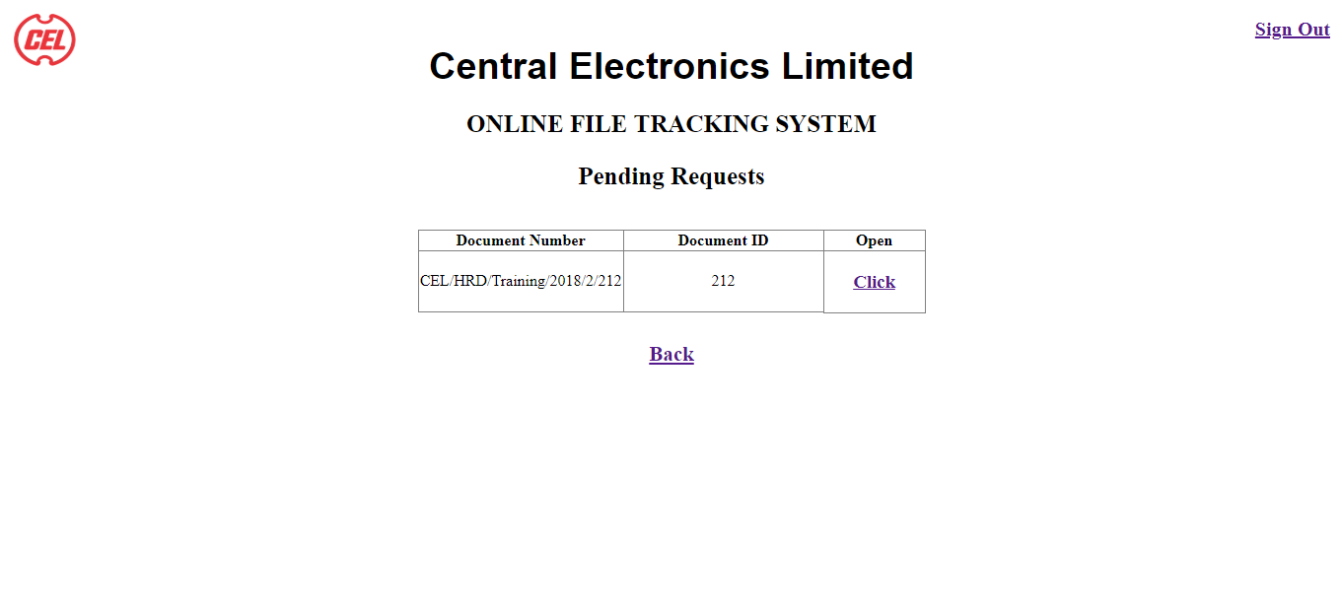

<!DOCTYPE html>

<html>

<head>

<title> CEL </title>

<link rel="stylesheet" type="text/css" href="style.css">

</head>

<body>

<img src = "imgs/logo.png">

<h3 style= "font-family : 'Arial'; font-size : 38px; align : center;margin-top : -20px"> Central Electronics Limited </h3>

<h2 style = "position: absolute; top: 0; right: 0; font-size : 20px; margin-right: 15px; margin-top : 20px;">

<a href = "logout.php" >Sign Out</a>

</h2>

<h1 style= "font-family : 'book antique'; font-size : 25px; align : center; margin-top : -15px;"> ONLINE FILE TRACKING SYSTEM </h1>

<h1 style= "font-family : 'book antique'; font-size : 25px; align : center; margin-top : 25px;"> Pending Requests </h1>

<center>

<?php

include('session.php');

ini_set('display_errors',0);

$db = db_open();

$code=$_GET['id'];

$result = mysql_query( "SELECT * FROM emp WHERE code = '$code'" , $db );

$row = mysql_fetch_assoc($result);

$depart = $row['department'];

$desig = $row['designation'];

$sect = $row['section'];

$fetch = mysql_query("Select * from track2 where Dispatched_To = '$code' and Status = 'In-Transit'",$db);

$row1 = mysql_fetch_assoc($fetch);

if($row1)

{

echo "<div>";

$arr = array("Document Number" , "Document ID");

echo "<table rules='ALL' border = 1 style ='margin-top : 40px;'>";

foreach($arr as $item)

echo "<th style='min-width:200px;'>".$item."</th>";

echo "<th>"."Open"."</th>";

while($row1)

{

echo "<tr>";

foreach($row1 as $key=>$row)

{

if($key=="Doc_No" || $key=="Doc_id")

echo "<td align='center' style='min-width:100px;'>". $row ."</td>";

$doc_id = $row1["Doc_id"];

}

echo "<td style='min-width:100px; text-align : center'>";

echo "<h3 style= 'font-family : 'book antique';'>

<a href = 'req.php?id=".$code."&doc-id=".$doc_id."'> Click </a>

</h3>";

$row1 = mysql_fetch_assoc($fetch);

}

echo "</table>";

echo "</div>";

}

else

echo "<h1 style='margin-top: 50px;'>No Daks</h1>";

?>

<h3 style= "font-family : 'book antique'; font-size : 21px; align : center; margin-top : 30px;">

<a href = "home.php?user=<?php echo $code; ?>">Back</a>

</h3>

</center>

</body>

</html>

## Accepting a dak:

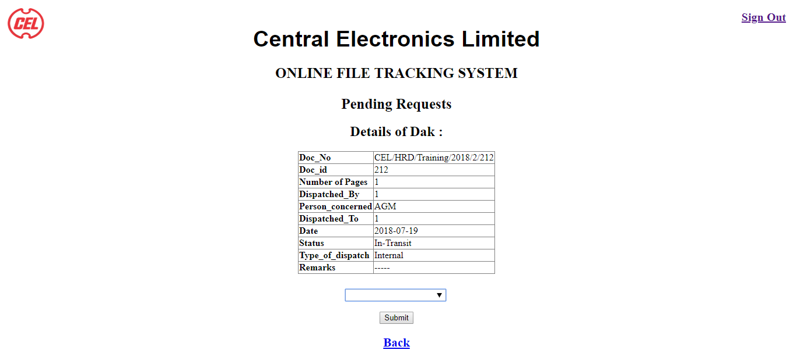

<!DOCTYPE html>

<html>

<head>

<title> CEL </title>

<link rel="stylesheet" type="text/css" href="style.css">

</head>

<script type="text/javascript">

</script>

<body>

<img src = "imgs/logo.png">

<h3 style= "font-family : 'Arial'; font-size : 38px; align : center;margin-top : -20px"> Central Electronics Limited </h3>

<h2 style = "position: absolute; top: 0; right: 0; font-size : 20px; margin-right: 15px; margin-top : 20px;">

<a href = "logout.php" >Sign Out</a>

</h2>

<h1 style= "font-family : 'book antique'; font-size : 25px; align : center; margin-top : -15px;"> ONLINE FILE TRACKING SYSTEM </h1>

<h1 style= "font-family : 'book antique'; font-size : 25px; align : center; margin-top : 25px;"> Pending Requests </h1>

<center>

<?php

include('session.php');

ini_set('display_errors',0);

$db = db_open();

$doc_id=$_GET['doc-id'];

$code = $_GET['id'];

$result = mysql_query( "SELECT * FROM emp WHERE code = '$code'" , $db );

$row = mysql_fetch_assoc($result);

mysql_query("SELECT * FROM track ORDER BY Date DESC",$db);

$fetch = mysql_query("Select * from track2 where Doc_id = '$doc_id' ORDER BY S_no DESC LIMIT 1",$db);

$row1 = mysql_fetch_assoc($fetch);

$i = 0;

$rid;

echo "<h2>"."Details of Dak :"."</h2>";

$arr = array("Doc_No" , "Doc_id" , "Number of Pages" , "Dispatched_By" , "Person_concerned" , "Dispatched_To" , "Date" , "Status", "Type_of_dispatch" , "Remarks");

echo "<table rules='ALL' border = 1 >";

foreach($row1 as $key=>$row)

{ if($row == null)

$row="-----";

if($key!="S_no")

{

echo "<tr>"."<th align='left'>".$arr[$i]."</th>";

echo "<td align='left'>". $row ."</td>";

echo "</tr>";

echo "</td>";

$i++;

}

}

echo "</table>";

$rid=$row1['Dispatched_By'];

if($_SERVER["REQUEST_METHOD"] == "POST")

{

$Stat= $_POST['Stat'];

$acc="Accepted";

if($Stat == "Accept")

{

mysql_query("Update track2 set Status='$acc' where Doc_id = '$doc_id' ORDER BY S_no DESC LIMIT 1",$db);

header("location: recreq.php?id=$code");

}

else

{

header("location: reject.php?id=$code&&doc-id=$doc_id");

}

}

?>

<form action = "" method = "post" style="margin-top:2%;">

<input list='Stat' name='Stat'>

<datalist id='Stat'>

<option value='Accept'>Accept</option>

<option value='Reject'>Reject</option>

</datalist>

<br />

<br />

<input type = "Submit" value = "Submit"/>

</form>

<h3 style= "font-family : 'book antique'; font-size : 21px; align : center; margin-top : 20px;">

<a href = "req.php?id=<?php echo $code; ?>&&doc-id=<?php echo $doc_id ?>">Back</a>

</h3>

</center>

</body>

</html>

## Rejecting a dak:



<!DOCTYPE html>

<html>

<head>

<title> CEL </title>

<link rel="stylesheet" type="text/css" href="style.css">

</head>

<script type="text/javascript">

</script>

<body>

<img src = "imgs/logo.png">

<h3 style= "font-family : 'Arial'; font-size : 38px; align : center;margin-top : -20px"> Central Electronics Limited </h3>

<h2 style = "position: absolute; top: 0; right: 0; font-size : 20px; margin-right: 15px; margin-top : 20px;">

<a href = "logout.php" >Sign Out</a>

</h2>

<h1 style= "font-family : 'book antique'; font-size : 25px; align : center; margin-top : -15px;"> ONLINE FILE TRACKING SYSTEM </h1>

<h1 style= "font-family : 'book antique'; font-size : 25px; align : center; margin-top : 25px;"> Pending Requests </h1>

<center>

<?php

include('session.php');

ini_set('display_errors',0);

$db = db_open();

$doc_id=$_GET['doc-id'];

$code = $_GET['id'];

$rej="Rejected";

$result = mysql_query( "SELECT * FROM emp WHERE code = '$code'" , $db );

$row = mysql_fetch_assoc($result);

mysql_query("SELECT * FROM track ORDER BY Date DESC",$db);

$fetch = mysql_query("Select * from track2 where Doc_id = '$doc_id' ORDER BY S_no DESC LIMIT 1",$db);

$row1 = mysql_fetch_assoc($fetch);

$rid=$row1['Dispatched_By'];

$ft = mysql_query("Select * from emp where code = '$rid'",$db);

$r = mysql_fetch_assoc($ft);

$per = $r['Person_concerned'];

$dat = Date('Y-m-d');

if($_SERVER["REQUEST_METHOD"] == "POST")

{

$remarks = $_POST['Remarks'];

mysql_query("Update track2 set Status = '$rej' , Remarks = '$remarks' where Doc_id = '$doc_id' LIMIT 1",$db);

$s = "Insert into track2 (`Doc_No` , `Doc_id` , `Pages` , `Dispatched_By` , `Person_concerned` , `Dispatched_To` , `Date` , `Status` , `Type_of_dispatch` , `Remarks`) values ('".$row1['Doc_No']."','".$row1['Doc_id']."','".$row1['Pages']."','".$code."','".$per."','".$rid."','".$dat."','In-Transit','".$row1['Type_of_dispatch']."','')";

mysql_query($s,$db);

header("location: recreq.php?id=$code");

}

?>

<form action = "" method = "post" style="margin-top:4%;">

<div id = "form" >

<label style="margin-top:2%;"> Reason to Reject : </label>

<br />

<input type = "text" name = "Remarks" class = "box" style="margin-top:2%;" required>

<br />

<br />

</div>

<input type = "Submit" value = "Submit" style="margin-top:3%;"/>

</form>

<h3 style= "font-family : 'book antique'; font-size : 21px; align : center; margin-top : 20px;">

<a href = "recreq.php?id=<?php echo $code; ?>">Back</a>

</h3>

</center>

</body>

</html>

## Received Daks :

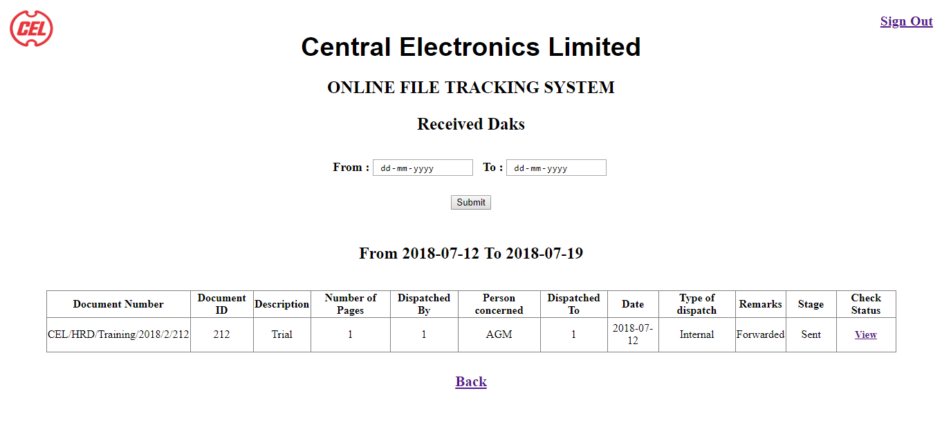

<!DOCTYPE html>

<html>

<head>

<title> CEL </title>

<link rel="stylesheet" type="text/css" href="style.css">

</head>

<body>

<img src = "imgs/logo.png">

<h3 style= "font-family : 'Arial'; font-size : 38px; align : center;margin-top : -20px"> Central Electronics Limited </h3>

<h2 style = "position: absolute; top: 0; right: 0; font-size : 20px; margin-right: 15px; margin-top : 20px;">

<a href = "logout.php" >Sign Out</a>

</h2>

<h1 style= "font-family : 'book antique'; font-size : 25px; align : center; margin-top : -15px;"> ONLINE FILE TRACKING SYSTEM </h1>

<h1 style= "font-family : 'book antique'; font-size : 25px; align : center; margin-top : 25px;"> Received Daks </h1>

<center>

<form action="" method="post" style = "margin-top : 3%">

<label > From : </label>

<input type="date" name="Date1" style= "text-align : center; margin-right:5px ; ">

<label style= "margin-left:5px"> To : </label>

<input type="date" name="Date2" style= "text-align : center;">

<br />

<br />

<input type="submit" name="srch" style = "margin-top : 10px">

</form>

</center>

<center>

<?php

include('session.php');

ini_set('display_errors',0);

$db = db_open();

$code=$_GET['id'];

$result = mysql_query( "SELECT * FROM emp WHERE code = '$code'" , $db );

$row = mysql_fetch_assoc($result);

$depart = $row['department'];

$desig = $row['designation'];

$sect = $row['section'];

if($_POST['srch'])

{

$date1=$_POST['Date1'];

$date2=$_POST['Date2'];

$datet=date('Y-m-d');

if($date1 > $date2)

echo '<script>',"alert('Invalid Period!');",'</script>';

if(($date1 > $datet) && ($date2 > $datet) )

echo '<script>',"alert('Invalid Date!');",'</script>';

if($date1 <= $date2 && $date1 <= $datet && $date2 <= $datet ) {

echo "<h2 style='margin-top: 50px;'>From ".$date1." To ".$date2."</h2>";

$fetch = mysql_query("Select * from track2 where Dispatched_To = '$code' and Status = 'Accepted' and Date between '$date1' and '$date2' ",$db);

$row1 = mysql_fetch_assoc($fetch);

if($row1)

{

echo "<div>";

$arr = array("Document Number" , "Document ID" , "Pages" , "Dispatched By" , "Person concerned" , "Dispatched To" , "Date" , "Type of dispatch" , "Remarks" , "Stage" , "Check Status");

echo "<table rules='ALL' border = 1 style ='margin-top : 40px;' >";

foreach($arr as $item)

echo "<th style='min-width:70px'>".$item."</th>";

while($row1)

{

$fetch5 = mysql_query("Select * from track where Doc_id = '".$row1['Doc_id']."'",$db);

$row5 = mysql_fetch_assoc($fetch5);

$stage = $row5['Stage'];

echo "<tr>";

foreach($row1 as $key=>$row)

{

if($row == null)

$row="-----";

if(($key!="S_no")&&($key!="Status"))

echo "<td align='center'>".$row."</td>";

}

echo "<td align = 'center'>".$stage."</td>";

echo "<td>

<h3 style = 'text-align : center; font-size : 15px'>

<a href = 'track.php?id=".$code."&&doc_id=".$row1['Doc_id']."'> View </a>

</h3>";

$row1 = mysql_fetch_assoc($fetch);

}

echo "</table>";

echo "</div>";

}

else

echo "<h1 style='margin-top: 50px;'>No Daks</h1>";

}

}

else{

$date = Date("Y-m-d");

$date_ago = date('Y-m-d', strtotime('-7 days'));

echo "<h2 style='margin-top: 50px;'>From ".$date_ago." To ".$date."</h2>";

$fetch = mysql_query("Select * from track2 where Dispatched_To = '$code' and Status = 'Accepted' and Date between '$date_ago' and '$date' ",$db);

$row1 = mysql_fetch_assoc($fetch);

if($row1)

{

echo "<div>";

$arr = array("Document Number" , "Document ID" , "Description" , "Number of Pages" , "Dispatched By" , "Person concerned" , "Dispatched To" , "Date" , "Type of dispatch" , "Remarks", "Stage" , "Check Status");

echo "<table rules='ALL' border = 1 style ='margin-top : 40px;' >";

foreach($arr as $item)

echo "<th style='min-width:70px'>".$item."</th>";

while($row1)

{

$fetch5 = mysql_query("Select * from track where Doc_id = '".$row1['Doc_id']."'",$db);

$row5 = mysql_fetch_assoc($fetch5);

$des = $row5['Description'];

$stage = $row5['Stage'];

$x=0;

echo "<tr>";

foreach($row1 as $key=>$row)

{

if($row == null)

$row="-----";

if($x==3)

echo "<td align='center'>".$des."</td>";

if(($key!="S_no")&&($key!="Status"))

echo "<td align='center'>".$row."</td>";

$x++;

}

echo "<td align = 'center'>".$stage."</td>";

echo "<td>

<h3 style = 'text-align : center; font-size : 15px'>

<a href = 'track.php?id=".$code."&&doc_id=".$row1['Doc_id']."'> View </a>

</h3>";

$row1 = mysql_fetch_assoc($fetch);

}

echo "</table>";

echo "</div>";

}

else

echo "<h1 style='margin-top: 50px;'>No Daks</h1>";

}

?>

<h3 style= "font-family : 'book antique'; font-size : 21px; align : center; margin-top : 30px;">

<a href = "home.php?user=<?php echo $code; ?>">Back</a>

</h3>

</center>

</body>

</html>

## Checking Status of Received dak:

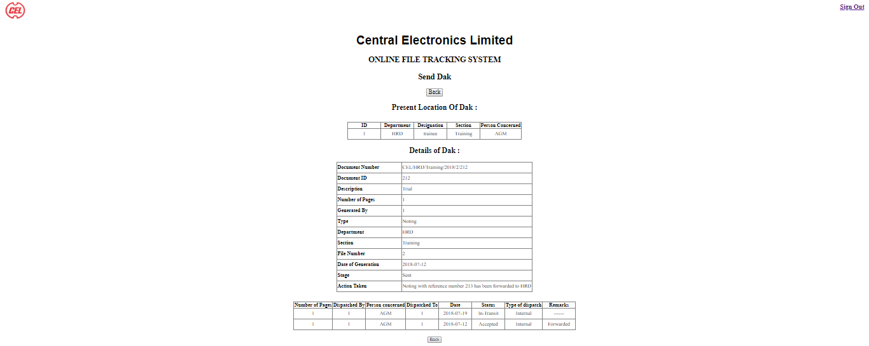

<!DOCTYPE html>

<html>

<head>

<title> CEL </title>

<link rel="stylesheet" type="text/css" href="style.css">

</head>

<?php

include('session.php');

ini_set('display_errors',0);

$db = db_open();

$code = $_GET['id'];

$result = mysql_query("SELECT * FROM emp WHERE code = '$code'" , $db);

$row = mysql_fetch_assoc($result);

?>

<body>

<img src = "imgs/logo.png">

<h3 style= "font-family : 'Arial'; font-size : 38px; align : center;margin-top : -20px"> Central Electronics Limited </h3>

<h2 style = "position: absolute; top: 0; right: 0; font-size : 20px; margin-right: 15px; margin-top : 20px;">

<a href = "logout.php" >Sign Out</a>

</h2>

<h1 style= "font-family : 'book antique'; font-size : 25px; align : center; margin-top : -15px;"> ONLINE FILE TRACKING SYSTEM </h1>

<h1 style= "font-family : 'book antique'; font-size : 25px; align : center; margin-top : 25px;"> Send Dak </h1>

<center>

<button style= "font-family : 'book antique'; font-size : 18px; align : center; margin-top : 2px;" onclick="history.go(-1);">Back </button>

<?php

{

$code = $_GET['id'];

$doc_id = $_GET['doc_id'];

$fetch4 = mysql_query("Select * from track Where Doc_id = '$doc_id' ",$db);

$row4 = mysql_fetch_assoc($fetch4);

$i = 0;

if($row4 != null)

{

echo "<h2 style = 'margin-top = 50px'>Present Location Of Dak :</h2>";

$fetch4 = mysql_query("Select * from track2 where Doc_id='$doc_id' order by S_no desc LIMIT 1",$db);

$row3 = mysql_fetch_assoc($fetch4);

$ids = $row3['Dispatched_To'];

$femp = mysql_query("Select * from emp where code = '$ids'",$db);

$row5 = mysql_fetch_assoc($femp);

if($row5)

{

echo "<div>";

$arr2 = array("ID" , "Department" , "Designation" , "Section" , "Person Concerned" );

echo "<table rules='ALL' border = 1 style ='margin-top : 30px; '>";

foreach($arr2 as $item)

echo "<th style='min-width:100px;'>".$item."</th>";

echo "<tr>";

foreach($row5 as $key=>$row)

{

if($key!="password")

echo "<td align='center' style='min-width:100px; height : 30px'>". $row ."</td>";

}

echo "</table>";

echo "</div>";

}

echo "<h2>"."Details of Dak :"."</h2>";

$ar = array("Document Number" , "Document ID" , "Description" , "Number of Pages" , "Generated By" , "Type" , "Department" , "Section" , "File Number" , "Date of Generation", "Stage" , "Action Taken" );

echo "<table rules='ALL' border = 1 >";

foreach($row4 as $key=>$row)

{ if($row == "")

$row = "------";

echo "<tr>"."<th align='left' style='min-width:200px; height : 30px'>".$ar[$i]."</th>";

echo "<td align='left' style='min-width:200px; height : 30px'>". $row ."</td>";

echo "</tr>";

echo "</td>";

$i++;

}

$fetch = mysql_query("Select * from track2 where Doc_id='$doc_id' order by S_no desc",$db);

$row1 = mysql_fetch_assoc($fetch);

if($row1)

{

echo "<div>";

$arr = array( "Number of Pages" , "Dispatched By" , "Person concerned" , "Dispatched To" , "Date" , "Status", "Type of dispatch" , "Remarks");

echo "<table rules='ALL' border = 1 style ='margin-top : 30px; '>";

foreach($arr as $item)

echo "<th>".$item."</th>";

while($row1)

{

echo "<tr>";

foreach($row1 as $key=>$row)

{

if($row == "")

$row = "------";

if($key!="S_no" && $key!= "Doc_No" && $key!= "Doc_id" )

echo "<td align='center' style='min-width:100px; height : 30px'>". $row ."</td>";

$doc_id = $row1["Doc_id"];

}

$row1 = mysql_fetch_assoc($fetch);

}

echo "</table>";

echo "</div>";

}

$get = mysql_query("Select * from ref where Ref_no = '$doc_id'",$db);

$refs = mysql_fetch_assoc($get);

while ($refs)

{

$i=0;

echo "<h2 style = 'margin-top = 50px'>Details of Dak generated in Reference</h2>";

$doc_id = $refs['Doc_id'];

echo "<h2 style = 'margin-top = 50px'>Present Location Of Dak :</h2>";

$fetch5 = mysql_query("Select * from track2 where Doc_id='$doc_id' order by S_no desc LIMIT 1",$db);

$row4 = mysql_fetch_assoc($fetch4);

$ids2 = $row3['Dispatched_To'];

$femp = mysql_query("Select * from emp where code = '$ids2'",$db);

$row6 = mysql_fetch_assoc($femp);

if($row6)

{

echo "<div>";

$arr3 = array("ID" , "Department" , "Designation" , "Section" , "Person Concerned" );

echo "<table rules='ALL' border = 1 style ='margin-top : 30px; '>";

foreach($arr3 as $item)

echo "<th style='min-width:100px;'>".$item."</th>";

echo "<tr>";

foreach($row6 as $key=>$row)

{

if($key!="password")

echo "<td align='center' style='min-width:100px; height : 30px'>". $row ."</td>";

}

echo "</table>";

echo "</div>";

}

$fetch6 = mysql_query("Select * from track Where Doc_id = '$doc_id' ",$db);

$row6 = mysql_fetch_assoc($fetch6);

echo "<h2>"."Details of Dak :"."</h2>";

$ar2 = array("Document Number" , "Document ID" , "Description" , "Number of Pages" , "Generated By" , "Type" , "Department" , "Section" , "File Number" , "Date of Generation", "Stage" , "Action Taken" );

echo "<table rules='ALL' border = 1 >";

foreach($row6 as $key=>$row)

{

if($row == "")

$row = "------";

echo "<tr>"."<th align='left' style='min-width:200px; height : 30px'>".$ar2[$i]."</th>";

echo "<td align='left' style='min-width:200px; height : 30px'>". $row ."</td>";

echo "</tr>";

echo "</td>";

$i++;

}

$fetch = mysql_query("Select * from track2 where Doc_id='$doc_id' order by S_no desc",$db);

$row1 = mysql_fetch_assoc($fetch);

if($row1)

{

echo "<div>";

$arr = array( "Number of Pages" , "Dispatched By" , "Person concerned" , "Dispatched To" , "Date" , "Status", "Type of dispatch" , "Remarks");

echo "<table rules='ALL' border = 1 style ='margin-top : 30px;'>";

foreach($arr as $item)

echo "<th>".$item."</th>";

while($row1)

{

echo "<tr>";

foreach($row1 as $key=>$row)

{

if($row == "")

$row = "------";

if($key!="S_no" && $key!= "Doc_No" && $key!= "Doc_id" )

echo "<td align='center' style='min-width:100px; height : 30px'>". $row ."</td>";

$doc_id = $row1["Doc_id"];

}

$row1 = mysql_fetch_assoc($fetch);

}

echo "</table>";

echo "</div>";

}

$refs = mysql_fetch_assoc($get);

}

}

else

echo "<h2>"."Dak not found"."</h2>";

}

echo "<button style = 'margin-top : 20px;' onclick='history.go(-1)'>Back </button>";

?>

</center>

</body>

</html>

## Pending Daks for Forwarding:

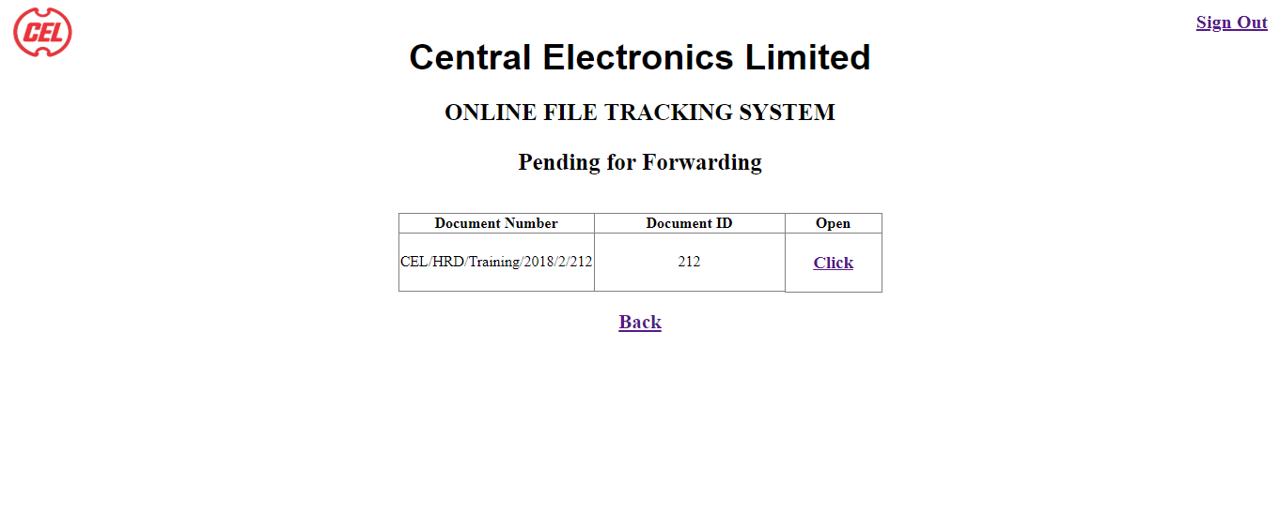

<!DOCTYPE html>

<html>

<head>

<title> CEL </title>

<link rel="stylesheet" type="text/css" href="style.css">

</head>

<body>

<center>

<img src = "imgs/logo.png">

<h3 style= "font-family : 'Arial'; font-size : 38px; align : center;margin-top

: -20px"> Central Electronics Limited </h3>

<h2 style= "position: absolute; top: 0; right: 0;font-size : 20px; margin-

right: 15px; margin-top : 20px;">

<a href = "logout.php" >Sign Out</a>

</h2>

<h1 style= "font-family : 'book antique'; font-size : 25px; align : center; margin-top : -15px;"> ONLINE FILE TRACKING SYSTEM </h1>

<h1 style= "font-family : 'book antique'; font-size : 25px; align : center; margin-top : 25px;"> Pending for Forwarding </h1>

<?php

include('session.php');

ini_set('display_errors',0);

$db = db_open();

$code=$_GET['id'];

$result = mysql_query( "SELECT * FROM emp WHERE code = '$code'" , $db );

$row = mysql_fetch_assoc($result);

$depart = $row['department'];

$desig = $row['designation'];

$sect = $row['section'];

$fetch = mysql_query("Select * from track2 where Dispatched_To = '$code' and Status = 'Accepted' and Remarks != 'Forwarded' order by Doc_id desc",$db);

$row1 = mysql_fetch_assoc($fetch);

if($row1)

{

echo "<div>";

$arr = array("Document Number" , "Document ID");

echo "<table rules='ALL' border = 1 style ='margin-top : 40px;'>";

foreach($arr as $item)

echo "<th style='min-width:200px;'>".$item."</th>";

echo "<th>"."Open"."</th>";

while($row1)

{

echo "<tr>";

foreach($row1 as $key=>$row)

{

if($key=="Doc_No" || $key=="Doc_id")

echo "<td align='center' style='min-width:100px;'>". $row ."</td>";

$doc_id = $row1["Doc_id"];

}

echo "<td style='min-width:100px; text-align : center'>";

echo "<h3 style= 'font-family : 'book antique';'>

<a href = 'Sending.php?id=".$code."&doc-id=".$doc_id."'> Click </a>

</h3>";

$row1 = mysql_fetch_assoc($fetch);

}

echo "</table>";

echo "</div>";

}

else

echo "<h1 style='margin-top: 100px;'>No Daks</h1>";

?>

<h3 style= "font-family : 'book antique'; font-size : 21px; align : center; margin-top : 20px;">

<a href = "home.php?user=<?php echo $code; ?>">Back</a>

</h3>

</center>

</body>

</html>

## Sending a Dak:

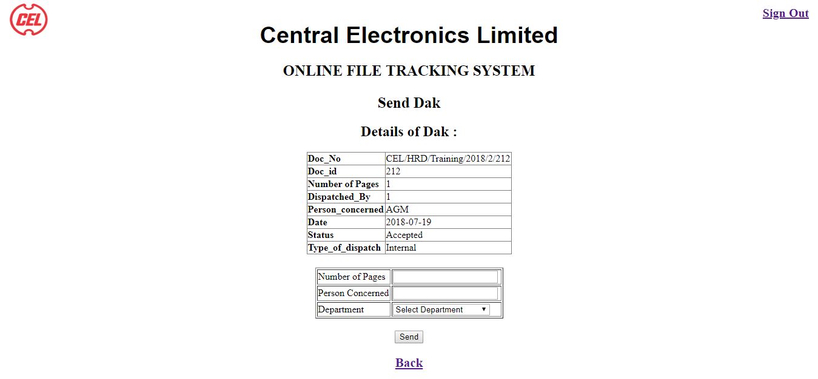

<!DOCTYPE html>

<html>

<head>

<title> CEL </title>

<link rel="stylesheet" type="text/css" href="style.css">

</head>

<body>

<img src = "imgs/logo.png">

<h3 style= "font-family : 'Arial'; font-size : 38px; align : center;margin-top : -

20px"> Central Electronics Limited </h3>

<h2 style = "position: absolute; top: 0; right: 0; font-size : 20px; margin-right: 15px; margin-top : 20px;">

<a href = "logout.php" >Sign Out</a>

</h2>

<h1 style= "font-family : 'book antique'; font-size : 25px; align : center; margin-

top : -15px;"> ONLINE FILE TRACKING SYSTEM </h1>

<h1 style= "font-family : 'book antique'; font-size : 25px; align : center; margin-

top : 25px;"> Send Dak </h1>

<center>

<?php

include('session.php');

ini_set('display_errors',0);

$db = db_open();

$doc_id=$_GET['doc-id'];

$code = $_GET['id'];

$result = mysql_query( "SELECT * FROM emp WHERE code = '$code'" , $db );

$row = mysql_fetch_assoc($result);

$depart = $row['department'];

$fetch = mysql_query("Select * from track2 where Doc_id = '$doc_id' order by S_no desc LIMIT 1",$db);

$row1 = mysql_fetch_assoc($fetch);

$doc_no=$row1['Doc_No'];

$sno= $row1['S_no'];

$i = 0;

$rid;

echo "<h2>"."Details of Dak :"."</h2>";

$arr = array("Doc_No" , "Doc_id" , "Number of Pages" , "Dispatched_By" , "Person_concerned", "Date" , "Status", "Type_of_dispatch" );

echo "<table rules='ALL' border = 1 >";

foreach($row1 as $key=>$row)

{ if($row == null)

$row="-----";

if($key!="Dispatched_To"&& $key!="S_no" && $key!="Remarks")

{

echo "<tr>"."<th align='left'>".$arr[$i]."</th>";

echo "<td align='left'>". $row ."</td>";

echo "</tr>";

echo "</td>";

$i++;

}

}

echo "</table>";

$rid=$row1['Dispatched_By'];

$num=0;

if($_SERVER["REQUEST_METHOD"] == "POST")

{

$pgs=$_POST['pgs'];

$pcon=$_POST['pcon'];

$dep=$_POST['dep'];

if($dep == $depart)

$type = "Internal";

else

$type = "External";

$status = "In-Transit";

$date = date('Y-m-d');

$fetch1 = mysql_query("Select * from emp Where Person_concerned = '$pcon'",$db);

$row1 = mysql_fetch_assoc($fetch1);

$dto = $row1['code'];

mysql_query("Insert into track2(`Doc_No` , `Doc_id` , `Pages` , `Dispatched_By` ,

`Person_concerned` , `Dispatched_To` , `Date` , `Status`, `Type_of_dispatch`, `Remarks`) values

('$doc_no','$doc_id','$pgs','$code','$pcon','$dto','$date','$status','$type' , '')",$db);

mysql_query("UPDATE track2 set Remarks = 'Forwarded' where S_no = '$sno'",$db);

$num=1;

}

if($num==1)

{

header("location: send.php?id=$code");

}

?>

<form action = "" method = "post" style="margin-top:2%;">

<table id="table" border : "1" >

<div>

<tr>

<td>Number of Pages</td>

<td>

<input type="number" name="pgs" size="30" min="1" step="1" onkeypress='return

event.charCode >= 48 && event.charCode <= 57' required>

</td>

</tr>

<tr>

<td> Person Concerned </td>

<td>

<input list="Person Concerned" name="pcon" required>

<datalist id="Person Concerned">

<option value="GM">GM</option>

<option value="AGM">AGM</option>

<option value="ED">ED</option>

<option value="TO">TO</option>

<option value="CM">CM</option>

<option value="CMD">CMD</option>

</datalist>

<br />

<tr>

<td> Department </td>

<td>

<Select id="dep" list="dep" name="dep" style = "margin-top : 1px; width : 160px" required>

<option selected disabled value="">Select Department</option>

<option value="HRD">HRD</option>

<option value="MED">MED</option>

<option value="SPD">SPD</option>

</Select>

<br />

</td>

</tr>

</div>

</table>

<input type = "Submit" style = "margin-top : 20px" value = "Send" onclick = "alert('Dak Sent');" />

</form>

<h3 style= "font-family : 'book antique'; font-size : 21px; align : center; margin-top : 20px;">

<a href = "send.php?id=<?php echo $code; ?>">Back</a>

</h3>

</center>

</body>

</html>

## List of Generated Daks:

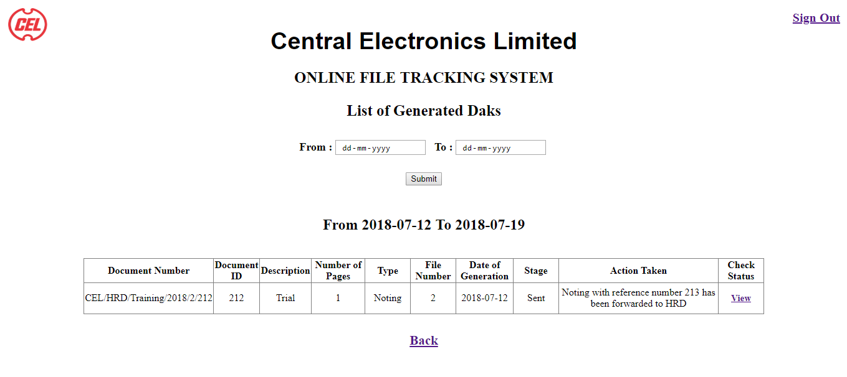

<!DOCTYPE html>

<html>

<head>

<title> CEL </title>

<link rel="stylesheet" type="text/css" href="style.css">

</head>

<body>

<img src = "imgs/logo.png">

<h3 style= "font-family : 'Arial'; font-size : 38px; align : center;margin-top : -

20px"> Central Electronics Limited </h3>

<h2 style = "position: absolute; top: 0; right: 0; font-size : 20px; margin-right: 15px;

margin-top : 20px;">

<a href = "logout.php" >Sign Out</a>

</h2>

<h1 style= "font-family : 'book antique'; font-size : 25px; align : center; margin-

top : -15px;"> ONLINE FILE TRACKING SYSTEM </h1>

<h1 style= "font-family : 'book antique'; font-size : 25px; align : center; margin-

top : 25px;"> List of Generated Daks </h1>

<center>

<form action="" method="post" style = "margin-top : 3%">

<label > From : </label>

<input type="date" name="Date1" style= "text-align : center; margin-right:5px ; ">

<label style= "margin-left:5px"> To : </label>

<input type="date" name="Date2" style= "text-align : center;">

<br />

<br />

<input type="submit" name="srch" style = "margin-top : 10px">

</form>

</center>

<center>

<?php

include('session.php');

ini_set('display_errors',0);

$db = db_open();

$code=$_GET['id'];

$result = mysql_query( "SELECT * FROM emp WHERE code = '$code'" , $db );

$row = mysql_fetch_assoc($result);

$depart = $row['department'];

$desig = $row['designation'];

$sect = $row['section'];

if($_POST['srch'])

{

$date1=$_POST['Date1'];

$date2=$_POST['Date2'];

$datet=date('Y-m-d');

if($date1 > $date2)

echo '<script>',"alert('Invalid Period!');",'</script>';

if( $date1 > $datet && $date2 > $datet )

echo '<script>',"alert('Invalid Date!');",'</script>';

if($date1 <= $date2 && $date1 <= $datet && $date2 <= $datet ) {

echo "<h2 style='margin-top: 50px;'>From ".$date1." To ".$date2."</h2>";

$fetch = mysql_query("Select * from track where Generated_by = '$code' and

Date_of_Generation between '$date1' and '$date2' order by Date_of_Generation

desc",$db);

$row1 = mysql_fetch_assoc($fetch);

$fetch5 = mysql_query("Select * from track where Doc_id = '".$row1['Doc_id']."'",$db);

$row5 = mysql_fetch_assoc($fetch5);

$stage = $row5['Stage'];

if($row1)

{

echo "<div>";

$arr = array("Document Number" , "Document ID" , "Description" , "Number of

Pages" , "Type" , "File Number" , "Date of Generation" , "Stage" , "Action

Taken" , "Check Status");

echo "<table rules='ALL' border = 1 style ='margin-top : 40px;'>";

foreach($arr as $item)

echo "<th style='min-width:70px'>".$item."</th>";

while($row1)

{

echo "<tr>";

foreach($row1 as $key=>$row)

{

if($row == null)

$row="-----";

if(($key!="Department")&&($key!="Section")&&($key!="Generated_by"))

echo "<td align='center'>".$row."</td>";

}

echo "<td>

<h3 style = 'text-align : center; font-size : 15px'>

<a href = 'track.php?id=".$code."&&doc_id=".$row1['Doc_id']."'> View </a>

</h3>";

$row1 = mysql_fetch_assoc($fetch);

}

echo "</table>";

echo "</div>";

}

else

echo "<h1 style='margin-top: 50px;'>No Daks</h1>";

}

}

else{

$date = Date("Y-m-d");

$date_ago = date('Y-m-d', strtotime('-7 days'));

echo "<h2 style='margin-top: 50px;'>From ".$date_ago." To ".$date."</h2>";

$fetch = mysql_query("Select * from track where Generated_by = '$code' and

Date_of_Generation between '$date_ago' and '$date' order by Date_of_Generation desc",$db);

$row1 = mysql_fetch_assoc($fetch);

if($row1)

{

echo "<div>";

$arr = array("Document Number" , "Document ID" , "Description" , "Number of Pages" , "Type" , "File Number" , "Date of Generation" , "Stage" , "Action Taken" , "Check Status");

echo "<table rules='ALL' border = 1 style ='margin-top : 40px;' >";

$fetch5 = mysql_query("Select * from track where Doc_id = '".$row1['Doc_id']."'",$db);

$row5 = mysql_fetch_assoc($fetch5);

$stage = $row5['Stage'];

foreach($arr as $item)

echo "<th style='min-width:70px'>".$item."</th>";

while($row1)

{

echo "<tr>";

foreach($row1 as $key=>$row)

{

if($row == null)

$row="-----";

if(($key!="Department")&&($key!="Section")&&($key!="Generated_by"))

echo "<td align='center'>".$row."</td>";

}

echo "<td>

<h3 style = 'text-align : center; font-size : 15px'>

<a href = 'track.php?id=".$code."&&doc_id=".$row1['Doc_id']."'> View </a>

</h3>";

$row1 = mysql_fetch_assoc($fetch);

}

echo "</table>";

echo "</div>";

}

else

echo "<h1 style='margin-top: 50px;'>No Daks</h1>";

}

?>

<h3 style= "font-family : 'book antique'; font-size : 21px; align : center; margin-top : 30px;">

<a href = "home.php?user=<?php echo $code; ?>">Back</a>

</h3>

</center>

</body>

</html>

## Tracking a Dak by dak number:

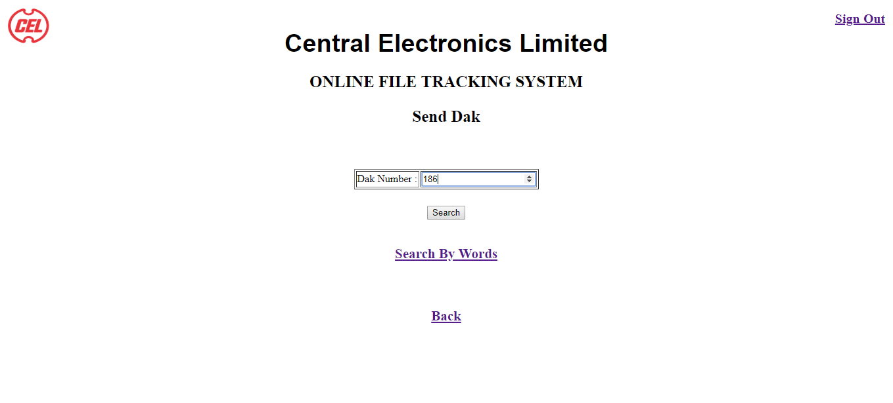

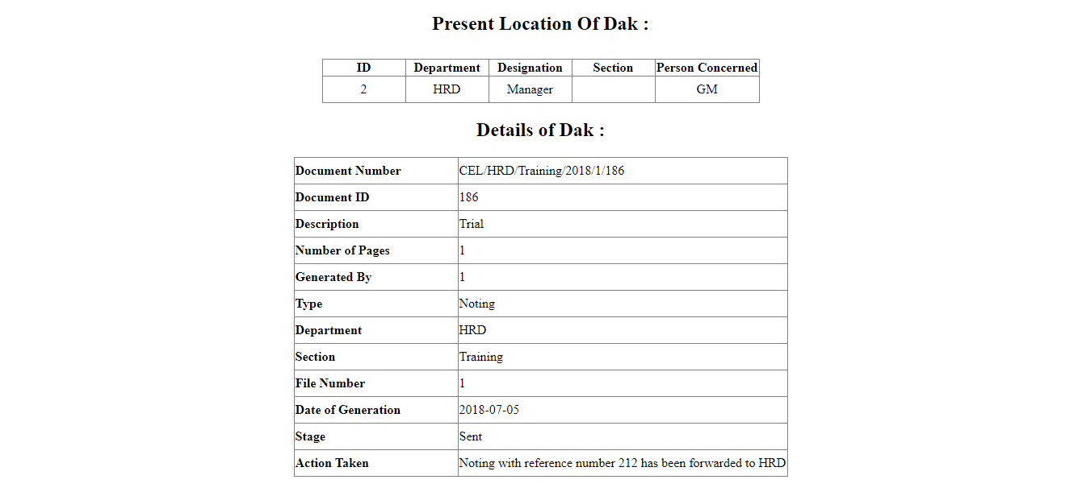

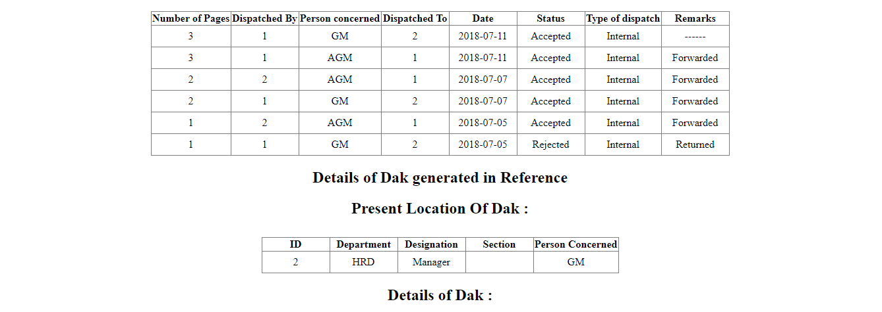

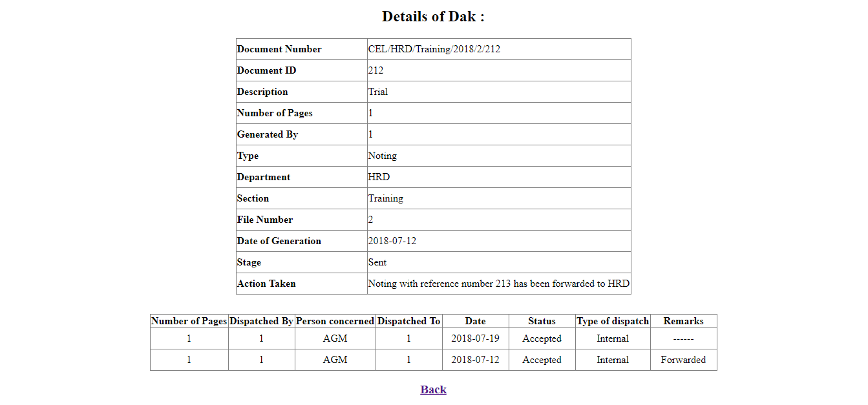

<!DOCTYPE html>

<html>

<head>

<title> CEL </title>

<link rel="stylesheet" type="text/css" href="style.css">

</head>

<?php

include('session.php');

ini_set('display_errors',0);

$db = db_open();

$code = $_GET['id'];

$result = mysql_query("SELECT * FROM emp WHERE code = '$code'" , $db);

$row = mysql_fetch_assoc($result);

?>

<body>

<img src = "imgs/logo.png">

<h3 style= "font-family : 'Arial'; font-size : 38px; align : center;margin-

top : -20px"> Central Electronics Limited </h3>

<h2 style = "position: absolute; top: 0; right: 0; font-size : 20px; margin-

right: 15px; margin-top : 20px;">

<a href = "logout.php" >Sign Out</a>

</h2>

<h1 style= "font-family : 'book antique'; font-size : 25px; align : center;

margin-top : -15px;"> ONLINE FILE TRACKING SYSTEM </h1>

<h1 style= "font-family : 'book antique'; font-size : 25px; align : center;

margin-top : 25px;"> Send Dak </h1>

<center>

<form action = "" method = "post" style="margin-top:6%;">

<div>

<table id="table" border : "1" >

<tr>

<td>Dak Number :</td>

<td>

<input type="number" name="Dak" size="30" required>

</td>

</tr>

</table>

<input type = "Submit" name = "num" style = "margin-top : 25px" value = "Search" />

</div>

</form>

</center>

<center>

<h3 style= "font-family : 'book antique'; font-size : 21px; align : center; margin-top :

40px; padding-bottom: 30px;">

<a href = "swrd.php?user=<?php echo $code; ?>">Search By Words</a>

</h3>

<h3 style= "font-family : 'book antique'; font-size : 21px; align : center; margin-top :

40px; padding-bottom: 30px;">

<a href = "Home.php?user=<?php echo $code; ?>">Back</a>

</h3>

<?php

if($_POST['num'])

{

$doc_id = $_POST['Dak'];

$fetch4 = mysql_query("Select * from track Where Doc_id = '$doc_id' ",$db);

$row4 = mysql_fetch_assoc($fetch4);

$i = 0;

if($row4 != null)

{

echo "<h2 style = 'margin-top = 50px'>Present Location Of Dak :</h2>";

$fetch4 = mysql_query("Select * from track2 where Doc_id='$doc_id' order by S_no

desc LIMIT 1",$db);

$row3 = mysql_fetch_assoc($fetch4);

$ids = $row3['Dispatched_To'];

$femp = mysql_query("Select * from emp where code = '$ids'",$db);

$row5 = mysql_fetch_assoc($femp);

if($row5)

{

echo "<div>";

$arr2 = array("ID" , "Department" , "Designation" , "Section" , "Person

Concerned" );

echo "<table rules='ALL' border = 1 style ='margin-top : 30px; '>";

foreach($arr2 as $item)

echo "<th style='min-width:100px;'>".$item."</th>";

echo "<tr>";

foreach($row5 as $key=>$row)

{

if($key!="password")

echo "<td align='center' style='min-width:100px; height : 30px'>". $row

."</td>";

}

echo "</table>";

echo "</div>";

}

echo "<h2>"."Details of Dak :"."</h2>";

$ar = array("Document Number" , "Document ID" , "Description" , "Number of Pages" ,

"Generated By" , "Type" , "Department" , "Section" , "File Number" , "Date of

Generation", "Stage" , "Action Taken" );

echo "<table rules='ALL' border = 1 >";

foreach($row4 as $key=>$row)

{

if($row == "")

$row = "------";

echo "<tr>"."<th align='left' style='min-width:200px; height :

30px'>".$ar[$i]."</th>";

echo "<td align='left' style='min-width:200px; height : 30px'>". $row ."</td>";

echo "</tr>";

echo "</td>";

$i++;

}

$fetch = mysql_query("Select * from track2 where Doc_id='$doc_id' order by S_no

desc",$db);

$row1 = mysql_fetch_assoc($fetch);

if($row1)

{

echo "<div>";

$arr = array( "Number of Pages" , "Dispatched By" , "Person concerned" ,

"Dispatched To" , "Date" , "Status", "Type of dispatch" , "Remarks");

echo "<table rules='ALL' border = 1 style ='margin-top : 30px;'>";

foreach($arr as $item)

echo "<th>".$item."</th>";

while($row1)

{

echo "<tr>";

foreach($row1 as $key=>$row)

{

if($row == "")

$row = "------";

if($key!="S_no" && $key!= "Doc_No" && $key!= "Doc_id" )

echo "<td align='center' style='min-width:100px; height :

30px'>". $row ."</td>";

$doc_id = $row1["Doc_id"];

}

$row1 = mysql_fetch_assoc($fetch);

}

echo "</table>";

echo "</div>";

}

$get = mysql_query("Select * from ref where Ref_no = '$doc_id'",$db);

$refs = mysql_fetch_assoc($get);

while ($refs)

{

$i=0;

echo "<h2 style = 'margin-top = 50px'>Details of Dak generated in

Reference</h2>";

$doc_id = $refs['Doc_id'];

echo "<h2 style = 'margin-top = 50px'>Present Location Of Dak :</h2>";

$fetch5 = mysql_query("Select * from track2 where Doc_id='$doc_id' order by

S_no desc LIMIT 1",$db);

$row4 = mysql_fetch_assoc($fetch4);

$ids2 = $row3['Dispatched_To'];

$femp = mysql_query("Select * from emp where code = '$ids2'",$db);

$row6 = mysql_fetch_assoc($femp);

if($row6)

{

echo "<div>";

$arr3 = array("ID" , "Department" , "Designation" , "Section" , "Person

Concerned" );

echo "<table rules='ALL' border = 1 style ='margin-top : 30px; '>";

foreach($arr3 as $item)

echo "<th style='min-width:100px;'>".$item."</th>";

echo "<tr>";

foreach($row6 as $key=>$row)

{

if($key!="password")

echo "<td align='center' style='min-width:100px; height : 30px'>". $row ."</td>";

}

echo "</table>";

echo "</div>";

}

$fetch6 = mysql_query("Select * from track Where Doc_id = '$doc_id' ",$db);

$row6 = mysql_fetch_assoc($fetch6);

echo "<h2>"."Details of Dak :"."</h2>";

$ar2 = array("Document Number" , "Document ID" , "Description" , "Number of Pages" , "Generated By" , "Type" , "Department" , "Section" , "File Number" , "Date of Generation", "Stage" , "Action Taken" );

echo "<table rules='ALL' border = 1 >";

foreach($row6 as $key=>$row)

{

if($row == "")

$row = "------";

echo "<tr>"."<th align='left' style='min-width:200px; height : 30px'>".$ar2[$i]."</th>";

echo "<td align='left' style='min-width:200px; height : 30px'>". $row ."</td>";

echo "</tr>";

echo "</td>";

$i++;

}

$fetch = mysql_query("Select * from track2 where Doc_id='$doc_id' order by S_no desc",$db);

$row1 = mysql_fetch_assoc($fetch);

if($row1)

{

echo "<div>";

$arr = array( "Number of Pages" , "Dispatched By" , "Person concerned" , "Dispatched To" , "Date" , "Status", "Type of dispatch" , "Remarks");

echo "<table rules='ALL' border = 1 style ='margin-top : 30px;'>";

foreach($arr as $item)

echo "<th>".$item."</th>";

while($row1)

{

echo "<tr>";

foreach($row1 as $key=>$row)

{

if($row == "")

$row = "------";

if($key!="S_no" && $key!= "Doc_No" && $key!= "Doc_id" )

echo "<td align='center' style='min-width:100px; height : 30px'>". $row ."</td>";

$doc_id = $row1["Doc_id"];

}

$row1 = mysql_fetch_assoc($fetch);

}

echo "</table>";

echo "</div>";

}

$refs = mysql_fetch_assoc($get);

}

echo "<h3 style= 'font-family : 'book antique'; font-size : 21px; align : center; margin-top : 40px; padding-bottom: 20px;'>

<a href = 'Home.php?user=".$code."'>Back</a>

</h3>";

}

else

echo "<h2>"."Dak not found"."</h2>";

}

?>

</center>

</body>

</html>

## Searching a dak by specific word:

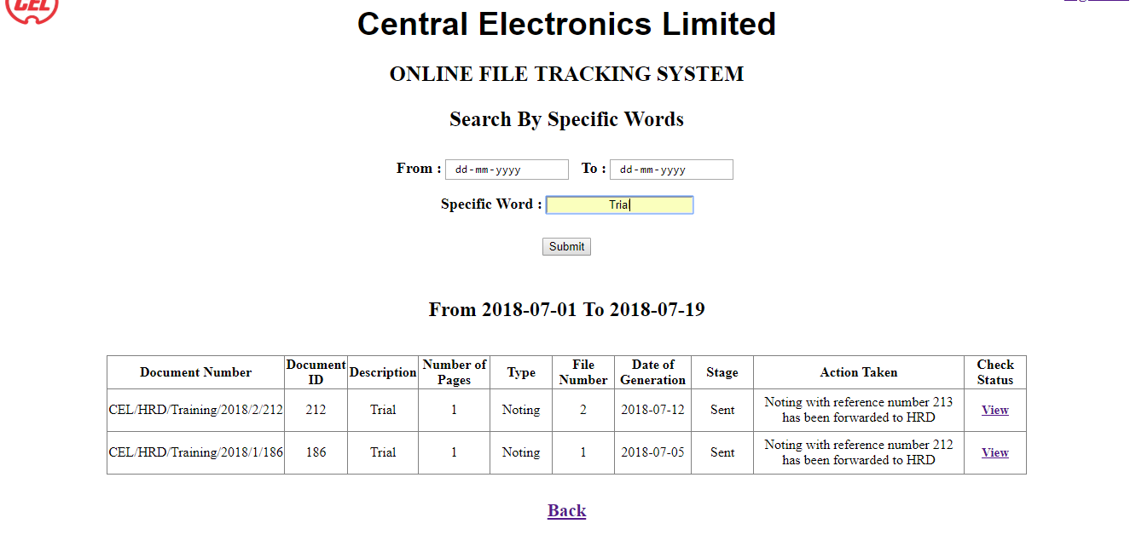

<!DOCTYPE html>

<html>

<head>

<title> CEL </title>

<link rel="stylesheet" type="text/css" href="style.css">

</head>

<body>

<img src = "imgs/logo.png">

<h3 style= "font-family : 'Arial'; font-size : 38px; align : center;margin-top : -20px"> Central Electronics Limited </h3>

<h2 style = "position: absolute; top: 0; right: 0; font-size : 20px; margin-right: 15px; margin-top : 20px;">

<a href = "logout.php" >Sign Out</a>

</h2>

<h1 style= "font-family : 'book antique'; font-size : 25px; align : center; margin-top : -15px;"> ONLINE FILE TRACKING SYSTEM </h1>

<h1 style= "font-family : 'book antique'; font-size : 25px; align : center; margin-top : 25px;"> Search By Specific Words </h1>

<center>

<form action="" method="post" style = "margin-top : 3%">

<label > From : </label>

<input type="date" name="Date1" style= "text-align : center; margin-right:5px ; ">

<label style= "margin-left:5px"> To : </label>

<input type="date" name="Date2" style= "text-align : center;">

<br />

<br />

<label style= "margin-left:5px"> Specific Word : </label>

<input type="text" name="wrd" style= "text-align : center;">

<br />

<br />

<input type="submit" name="srch" style = "margin-top : 10px">

</form>

</center>

<center>

<?php

include('session.php');

ini_set('display_errors',0);

$db = db_open();

$code=$_GET['user'];

$result = mysql_query( "SELECT * FROM emp WHERE code = '$code'" , $db );

$row = mysql_fetch_assoc($result);

$depart = $row['department'];

$desig = $row['designation'];

$sect = $row['section'];

if($_POST['srch'])

{

$date1=$_POST['Date1'];

$date2=$_POST['Date2'];

$wrd=$_POST['wrd'];

$datet=date('Y-m-d');

if($date1 > $date2)

echo '<script>',"alert('Invalid Period!');",'</script>';

if( $date1 > $datet && $date2 > $datet )

echo '<script>',"alert('Invalid Date!');",'</script>';

if($date1 <= $date2 && $date1 <= $datet && $date2 <= $datet ) {

echo "<h2 style='margin-top: 50px;'>From ".$date1." To ".$date2."</h2>";

$fetch = mysql_query("Select * from track where Generated_by = '$code' and Date_of_Generation between '$date1' and '$date2' order by Date_of_Generation desc",$db);

$row1 = mysql_fetch_assoc($fetch);

$fetch5 = mysql_query("Select * from track where Doc_id = '".$row1['Doc_id']."'",$db);

$row5 = mysql_fetch_assoc($fetch5);

$stage = $row5['Stage'];

if($row1)

{

$des=$row1['Description'];

if(stripos($des,$wrd) !== false)

{

echo "<div>";

$arr = array("Document Number" , "Document ID" , "Description" , "Number of Pages" , "Type" , "File Number" , "Date of Generation" , "Stage" , "Action Taken" , "Check Status");

echo "<table rules='ALL' border = 1 style ='margin-top : 40px;'>";

foreach($arr as $item)

echo "<th style='min-width:70px'>".$item."</th>";

while($row1)

{

echo "<tr>";

foreach($row1 as $key=>$row)

{

if($row == null)

$row="-----";

if(($key!="Department")&&($key!="Section")&&($key!="Generated_by"))

echo "<td align='center'>".$row."</td>";

}

echo "<td>

<h3 style = 'text-align : center; font-size : 15px'>

<a href = track.php?id=".$code."&&doc_id=".$row1['Doc_id']."'> View </a>

</h3>";

$row1 = mysql_fetch_assoc($fetch);

}

echo "</table>";

echo "</div>";

}

else

echo "<h1 style='margin-top: 50px;'>No Daks</h1>";

}

}

}

else{

$date = Date("Y-m-d");

$date_ago = date('Y-m-d', strtotime('-7 days'));

echo "<h2 style='margin-top: 50px;'>From ".$date_ago." To ".$date."</h2>";

$fetch = mysql_query("Select * from track where Generated_by = '$code' and Date_of_Generation between '$date_ago' and '$date' order by Date_of_Generation desc",$db);

$row1 = mysql_fetch_assoc($fetch);

if($row1)

{

echo "<div>";

$arr = array("Document Number" , "Document ID" , "Description" , "Pages" , "Type" , "File Number" , "Date of Generation" , "Stage" , "Action Taken" , "Check Status");

echo "<table rules='ALL' border = 1 style ='margin-top : 40px;' >";

$fetch5 = mysql_query("Select * from track where Doc_id = '".$row1['Doc_id']."'",$db);

$row5 = mysql_fetch_assoc($fetch5);

$stage = $row5['Stage'];

foreach($arr as $item)

echo "<th style='min-width:70px'>".$item."</th>";

while($row1)

{

echo "<tr>";

foreach($row1 as $key=>$row)

{

if($row == null)

$row="-----";

if(($key!="Department")&&($key!="Section")&&($key!="Generated_by"))

echo "<td align='center'>".$row."</td>";

}

echo "<td>

<h3 style = 'text-align : center; font-size : 15px'>

<a href = 'track.php?id=".$code."&&doc_id=".$row1['Doc_id']."'> View </a>

</h3>";

$row1 = mysql_fetch_assoc($fetch);

}

echo "</table>";

echo "</div>";

}

else

echo "<h1 style='margin-top: 50px;'>No Daks</h1>";

}

?>

<h3 style= "font-family : 'book antique'; font-size : 21px; align : center; margin-top : 30px;">

<a href = "home.php?user=<?php echo $code; ?>">Back</a>

</h3>

</center>

</body>

</html>